University of Oxford

estateS services

Electrical Safety Rules

Issue Date: 4 November 2022

Issue: 2

ISSUE STATUS

|  |  |  |  |
| --- | --- | --- | --- |
| Issue No. | Date of Issue | Details | Produced by |
| 1 | 25/11/2021 | Draft Issue | JON |
| 2 | 04/11/2022 | Client comments incorporated | JON |

CONTENTS

CHAPTER 1: scope 7

1.1 Application 7

1.1.1 Site Specific. 7

1.2 Safety Policy 8

1.3 Objectives 8

1.4 General 8

1.5 Statutory Regulations 8

1.6 Ownership of These Electrical Safety Rules 9

1.7 Compliance with These Electrical Safety Rules 9

1.8 Objections 9

1.9 Responsibilities 10

1.10 Issue of These Electrical Safety Rules 10

1.11 Safety Equipment 11

1.12 Reporting 11

1.13 Methodology of HV/LV Control & Operation 12

1.14 OUES Electrical Safety Rules Structure 13

CHAPTER 2: Definitions 14

CHAPTER 3: Roles and Responsibilities 21

3.1 Designated Person (Head of Electrical Engineering Services) 21

3.2 Authorising Engineer (Electrical) (AE) 21

3.3 Authorised Person (Electrical) (AP) 22

3.3.1 Senior Authorised Person (Electrical) (SAP) 22

3.3.2 Duty Authorised Person (Electrical) (DAP) 23

3.3.3 Authorised Person (Electrical) 23

3.4 Person in Charge (PiC) 24

3.5 Competent Persons (Electrical) (CP) 25

3.6 Accompanying Safety Persons 25

3.7 Appointed Persons 26

CHAPTER 4: Demarcation Agreements 27

4.1 General 27

4.2 Handover 27

4.3 COMA 28

CHAPTER 5: general precautions 29

5.1 General 29

5.2 Incidents, Accidents and Dangerous Occurrences 29

5.3 Emergency Situations 29

5.4 Un-manned Sites 30

5.5 Management of Visitors 30

5.6 Locks, Keys and Key Security 30

5.7 Key Registers 31

5.8 Lost Safety Key Procedure 31

5.9 Control of Entry into Electrical Rooms and Enclosures 31

5.10 Display of Regulations, Instructions and Signage 32

5.11 Operational Restrictions 33

5.12 Personal Protective Equipment 33

CHAPTER 6: operating records 35

6.1 Document Cabinet (Electrical Systems) 35

6.2 Operational Procedure Manual (Electrical Systems) 35

6.3 Site Logbook (Electrical Systems) 36

CHAPTER 7: Operating Procedures 38

7.1 Risk Assessments 38

7.2 Safety Documents 38

7.3 Safety Programme 38

7.3.1 Contents of Safety Programmes 39

7.3.2 Implementing Safety Programmes 40

7.3.3 Completion of Safety Programmes 40

7.4 Isolation and Earthing Diagram (I&ED) 40

7.4.1 Implementing the Isolation and Earthing Diagram (I&ED) 41

7.4.2 Completion of the Work or Test 41

7.5 Switching Plan 41

7.6 Permit to Work (Electrical) (PTW) 41

7.6.1 Issue, Acceptance and Cancellation of Permits to Work 41

7.6.2 Completion of the Work 42

7.7 Standing Instruction 43

7.8 Sanction to Test (STT) 44

7.9 Limitation of Access (LoA) 44

7.10 Certificate for Live Working 45

7.10.1 Procedure for Issue of a Certificate for Live Working 46

7.10.2 Procedure for Cancelling a Certificate for Live Working 46

7.11 Certificate of Isolation & Earthing (CI&E) 47

7.11.1 Implementation of Certificate of Isolation and Earthing 48

7.11.2 Completion of Certificate of Isolation and Earthing 48

7.12 Statement of Site Familiarity (Electrical) (SoSF) 49

7.12.1 Procedure for issue of a SoSF 49

7.13 Common Requirements for Safety Control Documentation 49

7.14 Guidelines for the Use of Electronic Safety Documents 50

7.15 Lost or Missing Safety Documents 51

CHAPTER 8: SAFETY PRECAUTIONS FOR WORK ON HIGH VOLTAGE EQUIPMENT 52

8.1 General 52

8.2 Working in Sub-Stations or Switchrooms 52

8.3 High Voltage Switching 52

8.4 Live Voltage and Phasing Tests 53

8.5 Work on Multi Panel Switchboards 54

8.6 Withdrawable Equipment 54

8.7 General Precautions for Work on HV Equipment 54

8.8 Table HV1 - Procedures for Work on HV Equipment 55

8.9 Table HV2 - Procedures for Testing on HV Equipment 56

CHAPTER 9: SAFETY PRECAUTIONS FOR WORK ON LOW VOLTAGE EQUIPMENT 57

9.1 Switching Operations on Complex Low Voltage Distribution Systems 57

9.2 General Precautions for Work on LV Equipment 57

9.2.1 Transfer of System Control (ToSC) Procedure 57

9.3 Table LV1 - Procedures for Work on Complex LV Equipment 58

9.4 Table LV2 - Procedures For Working on or Testing Non-Complex Low Voltage Equipment or Systems 60

9.5 Inspection, Fault Finding and Testing of Live LV Equipment 61

9.6 Working On or Near Live Exposed Conductors 62

CHAPTER 10: SAFETY PRECAUTIONS FOR WORK ON PHOTO VOLTAIC DC SYSTEMS 63

10.1 Hazards 63

10.2 Live Working on Photo Voltaic (PV) Systems 63

10.3 Electric Shock Hazards Associated With PV Systems 64

CHAPTER 11: ELECTRICAL EQUIPMENT & ANCILLARIES 65

11.1 High Voltage Ring Main Equipment 65

11.2 Fixed Pattern Circuit Breakers 65

11.3 Insulation Medium 65

11.4 Voltage Transformers 66

11.5 Off-Load Isolators 66

11.6 Generators 66

11.7 Spiking of Cables 67

11.8 UPS Systems & Equipment 67

11.8.1 Battery Isolation & Safe Working 67

11.8.2 By-pass Systems 68

11.8.3 UPS Neutral Switching 68

11.8.4 Procedure for Planned Battery Works under a Certificate for Live Working 68

11.9 Interlocking Systems 69

11.10 Potentially Hot Equipment 69

11.11 Auxiliary Supplies 69

11.12 Fire Extinguishing Systems 69

11.12.1 Automatic Fire Extinguishing Systems 69

11.12.2 Portable Fire Extinguishers 69

11.12.3 Ventilation Following Discharge 70

CHAPTER 12: Training & Assessment of Competence 71

12.1 Training and Assessment 71

12.2 Authorising Engineer 71

12.3 Prospective Authorised Person 72

12.4 Authorised Person 72

12.5 Approved Authorised Person Training Courses 73

12.6 Competent Person / Person in Charge (PiC) 74

12.7 Contractors 74

CHAPTER 13: MONITORING & AUDIT 75

13.1 Validation Audits by the Designated Person 75

13.2 Authorising Engineer Audits 75

13.3 Authorised Person 76

APPENDIX 1: SAFETY DOCUMENTATION 77

Appendix 1.1. Electrical Safety Programme 77

Appendix 1.2. Electrical Switching Plan 78

Appendix 1.3. Isolation & Earthing Diagram 79

Appendix 1.4. Permit to Work (Electrical) 80

Appendix 1.5. Sanction to Test 81

Appendix 1.6. Certificate for Live Working 82

Appendix 1.7. Limitation of Access 86

Appendix 1.8. Certificate of Isolation & Earthing 87

Appendix 1.9. Standing Instruction 88

Appendix 1.10. Statement of Site Familiarity (Electrical) 89

Appendix 1.11. Demarcation Agreement 90

APPENDIX 2: appointment documents 91

Appendix 2.1. Appointment Procedure for an Authorising Engineer (Electrical) 91

Appendix 2.2. Senior AP (HV/LV) Competency Certificate 92

Appendix 2.3. AP HV Competency Certificate 93

Appendix 2.4. AP LV Competency Certificate 94

Appendix 2.5. Authorisation of Appointed Person Certificate. 95

APPENDIX 3: abbreviations, terminology and symbols 96

Appendix 3.1. Abbreviations 96

Appendix 3.2. Terminology 96

Appendix 3.3. Symbols 97

APPENDIX 4: Model Safety Signs 99

Appendix 4.1. Design Specification 99

Appendix 4.2. Permanent Safety Signs - HV 99

Appendix 4.3. Permanent Safety Signs - LV 100

Appendix 4.4. Temporary Safety Signs 101

# scope

* 1. Application

These Electrical Safety Rules apply to all properties managed by University of Oxford, Estates Services who are referred to as “OUES” throughout the remainder of these Electrical Safety Rules.

Electrical systems associated with the Functional Estate vary considerably in size and complexity. The procedures advocated in these Electrical Safety Rules therefore cannot cover every circumstance and consequently may, in specific instances, need to be supplemented by local written procedures. These local arrangements should only be considered when, in the opinion of the Authorising Engineer (Electrical), the guidance given in these Electrical Safety Rules is inadequate for the particular circumstances. Any such supplementary procedures must therefore maintain the same standards of safety outlined in these Electrical Safety Rules.

### Site Specific.

On arrival all persons must report to the Departmental Representative who will be identified by the person in the OUES Electrical Section who instructed the works. Those persons undertaking work need to be made aware of any hazards in the area of the work, and agree the procedures and any specific controls that may be required, for example, where access is needed to containment or chemical laboratories, or other restricted areas of the department. Additionally, Contractors must be aware of departmental arrangements for booking in on entry, emergency procedures in case of fire or evacuation, and the requirement and arrangements for reporting accidents, incidents and obtaining first aid.

The person in the OUES Electrical Section who instructed the works is responsible for bringing to the attention of the Contractor the possible presence of asbestos containing materials (ACMs) in any areas where the Contractor will work, by consulting the relevant Asbestos Register or the University’s Asbestos Coordinator. In addition, the Contractor is expected to liaise closely with the relevant Departmental Representative and the OUES contact to ensure that concerns are reported promptly and, if necessary, the work is halted for further investigation. Departmental electricians must also be aware of the potential presence of ACMs where they work by consulting the same sources of information, and work in compliance with the University’s policy on asbestos, UPS S9/10.

The OUES Electrical Section has and maintains a comprehensive record of the electrical systems under its control. In general, records take the form of block schematics and circuit charts for installations within buildings and operational schematics for external networks. The records are kept in both hard copy - paper - and electronic form. The Contractor must always submit details of any changes that have occurred on completion of the works to the OUES Electrical Section along with any test and inspection certificates required for compliance with BS7671

The OUES Electrical Inspector will monitor the activities of those undertaking work on the electrical systems that are the responsibility of BESC. It should be clearly understood that this is not a supervisory position: it is the duty of persons in control of the system to supervise those working upon it.

Access shall be provided for the Electrical Inspector to inspect the works: any unsafe working practice or unsafe condition observed by the Electrical Inspector will be brought formally to the OUES Electrical Section’s attention. This may result in the suspension or withdrawal of the Competent Person or of authorisation as described above

Any defect identified which could affect the safety of a person, or the integrity of the system, must be brought to the attention of the OUES Electrical Section. It is anticipated that the initial report will be verbal: this will be followed up in writing giving full details of the defect and the remedial action taken for circumstances where the defect created significant risk from the electrical system. For instances where the risk is not significant a record of the defect shall be made together with details of the remedial actions taken.

It should be noted that no circuit shall be made available for use until it has been fully completed and inspected and tested in accordance with BS7671 including checks to ensure that earthing arrangements and protective conductors (including main protective bonding conductors) are in place; and Any circuit that is incomplete or has yet to be fully inspected and tested must remain securely isolated at the supply end.

* 1. Safety Policy

This safety policy is to detail requirement of University Safety office policy S4/10 and dictates that all persons involved in work on Electrical Distribution Systems shall work in accordance with these Electrical Safety Rules. These Electrical Safety Rules are mandatory and enable OUES to comply with their statutory requirements by ensuring, as far as is reasonably practicable, a safe place of work.

All persons have a duty to make themselves fully conversant with the contents and ignorance of the requirements shall not be accepted as an excuse for neglect of duty.

* 1. Objectives

The objective of these Electrical Safety Rules is to establish safe working conditions and practices on all High and Low Voltage Distribution Systems under the control of OUES.

* 1. General

The rules apply to all Persons who may work on or use the Electrical Distribution Systems.

The rules may be supplemented by individual Codes of Practice and Technical Instructions relating to particular topics and must be read in conjunction with such codes.

These Electrical Safety Rules cannot be altered to suit site conditions unless approved by the Authorising Engineer (Electrical).

These Electrical Safety Rules shall be reviewed annually by OUES management or sooner following the introduction of new legislation, a major incident or a near miss.

* 1. Statutory Regulations

These Electrical Safety Rules are mandatory and are intended to supplement Statutory Regulations and shall not be interpreted as cancelling or nullifying any Statutory Regulations. The Health and Safety at Work Act 1974 has enabled many sets of regulations.

Those specifically applicable are the current versions of:

1. The Electricity at Work Regulations
2. The Electricity Safety, Quality and Continuity Regulations
3. The Construction (Design and Management) Regulations
4. The Management of Health and Safety at Work Regulations
5. Dangerous Substances and Explosive Atmospheres Regulations
6. Provision and Use of Work Equipment Regulations

These Electrical Safety Rules shall also be interpreted in the light of documents giving  
guidance on desirable procedures including but not limited to the current versions of:

1. The Memorandum of Guidance on the Electricity at Work Regulations – HS (R) 25
2. BS7671 Requirements for Electrical Installations and its associated guidance notes
3. HSE Guidance Note HS (G) 85 Electricity At Work Safe Working Practices
4. HSE Guidance Notes GS38 Electrical Test Equipment for use by Electricians
5. OUES electrical safety guidance notes and policies.
   1. Ownership of These Electrical Safety Rules

The responsibility for writing, reviewing, updating, issuing and applying these Electrical Safety Rules rests wholly with the Designated Person appointed by OUES who will retain the master copy. The current Designated Person is: - Head of Electrical Engineering Services within Estates Services.

* 1. Compliance with These Electrical Safety Rules

These Electrical Safety Rules shall be administered on all OUES sites within the functional Estate.

If exceptional circumstances arise where these Electrical Safety Rules cannot be applied in full, work shall only proceed after a full assessment of the risks, the production of detailed work method statements and the application of suitable and sufficient control measures.

Only the Designated Person can authorise variation from the Rules, and only following detailed discussions with senior OUES personnel. Should the design of a particular piece of apparatus prohibit the absolute application of the Rules, it will be necessary to revise an existing Safety Rule or write a new Safety Rule. The Designated Person has the sole responsibility for the change process, including the composition, training and implementation of the new Rule.

* 1. Objections

No person is expected to work in an unsafe manner. If any person receives an instruction which he considers presents a health, safety or environmental risk to him or any associated persons, the matter shall be referred to his immediate supervisor before starting work.

Should the supervisor be unable to find an acceptable safe solution, the matter shall be referred to the Head of Electrical Engineering Services & the Authorising Engineer (Electrical) for resolution.

* 1. Responsibilities

OUES is responsible for the provision of a safe place of work for all employees and all persons whose safety may be put at risk through OUES activities.

All OUES employees, consultants & contractors have a duty to comply with:

* United Kingdom legislation
* European Directives and regulations
* OUES safety requirements
* All applicable Regulations, Codes of Practice and Guidance Notes

The documents above are accepted best practice and have been adopted by OUES in preparing these Electrical Safety Rules.

All persons at work have the general duty to work safely and to comply in full with these Electrical Safety Rules. All persons at work shall take all reasonable care for the health and safety of themselves, their fellow workers and others, including members of the public.

No person shall be expected to work outside his/her level of competence. Training shall be provided before any additional responsibilities are given.

If through intentional action, carelessness or neglect, a person fails to comply with these Electrical Safety Rules and thereby causes danger to himself or others, that person shall be liable to disciplinary action.

All persons issued with these Electrical Safety Rules during their employment with OUES, have the mandatory duty to understand these Electrical Safety Rules and their personal individual roles and responsibilities.

Training, supervision and resources shall be provided by OUES to enable all persons to comply with these Electrical Safety Rules.

All works on Electrical Distribution Systems shall be planned and controlled by the application of suitable and sufficient control measures through work method statements and risk assessments.

The roles of the Authorising Engineer (Electrical) and Authorised Person (Electrical) are twofold:

* They shall ensure that the Electrical systems and equipment are fit for use,
* They shall ensure the safety of personnel who are using, or who are near, such equipment.

To ensure systems are fit for purpose, and can be operated and maintained in a safe manner, the Authorising Engineer (Electrical) and the Senior Authorised Person (Electrical) shall be consulted before major alterations to, or procurement of, major electrical equipment that could adversely affect the existing installation.

* 1. Issue of These Electrical Safety Rules

These Electrical Safety Rules shall be available to all persons who have a responsibility to undertake work on Electrical Distribution Systems at all sites where OUES have responsibility for management, design, operation or maintenance of Electrical Distribution Systems.

A copy of these Electrical Safety shall be issued to all employees and contractors nominated by:

* OUES Site Managers
* Authorising Engineer (Electrical)
* OU Senior Authorised Person (Electrical)
* OU Authorised Person (Electrical)
* Ext Authorised Person (Electrical)
* Appointed person (consultant / contractors / building manager)

The issue of these Electrical Safety Rules does not constitute the authorisation of work.

* 1. Safety Equipment

OUES shall supply and maintain for its employees, all equipment necessary to work safely. This will comprise all tools, safety equipment and personal protective clothing (PPE) required to comply with the approved procedure. Contractors are required to supply relevant tools, safety equipment and PPE for use by their staff.

It is the responsibility of all persons at work to take reasonable care of, and understand the need for the use of correct tools, safety equipment and PPE.

* 1. Reporting

The purpose of these procedures is to ensure that those persons, who operate or manage these Electrical Safety Rules, are involved in the accident and incident investigation process. The objective being to determine at first hand, any deficiencies or other implications for the Electrical Safety Rules or Electrical Distribution System, resulting from the accident or incident and to ensure that their findings are communicated to those persons responsible for maintaining the Electrical Safety Rules and the Electrical Distribution System.

Whenever an accident or near miss incident occurs to persons working within, or to persons affected as a result of activities carried out when working under the control of these Electrical Safety Rules, the Competent Person/Person in Charge in charge of the work on site; shall notify the Duty Authorised Person, as soon as is practicable, by phone or in person, of the details of the accident or incident. Should the Competent Person/Person in Charge be unable to do this, notification shall be carried out as soon as practicable. This notification requirement is in addition to any existing notification safety requirements, including notifying the Health and Safety Executive of reportable accidents or incidents.

The OU Authorised Person, when notified, shall immediately attend the scene of all accidents or incidents resulting from work carried out under the constraints of these Electrical Safety Rules, In addition to the primary role of making the scene safe and the protection of the building and business operations, the Authorised Person shall also determine whether the accident or incident was in any way connected to the proper or improper operation or adoption of these Electrical Safety Rules, or bypassing of the requirements of these Electrical Safety Rules.

The investigation shall include compliance with the safe system of work provided for the activity, the details of which shall be held within the site filing and record system. The objective of the investigation report shall not be to apportion blame, but to determine where, if at all, these Electrical Safety Rules failed to provide a safe working environment, either through lack of training, awareness, misinterpretation, or bypass of the requirements of these Electrical Safety Rules.

The Authorised Person shall submit a report to the Authorising Engineer (Electrical) within forty-eight hours, either as part of a larger report or as a standalone report, describing the findings.

**The report shall be submitted to the following persons:**

* Authorising Engineer (Electrical)
* All other Authorising Engineer(s) for the discipline(s) concerned with the work activity
* OUES Designated Person
  1. Methodology of HV/LV Control & Operation

The following outlines the methodology adopted by OUES for the safe control and operation of HV & LV equipment, networks, and control of access into HV & LV areas.

**High Voltage:**

1. Supply of 11kV power to the campus is via a Joint Operational Agreement between OUES and Southern Electric Power Distribution (SEPD). Circuit breaker status is remotely monitored via a SEPD SCADA system and remote close control provision is made to enable power restoration. Prior permission must be sought by OUES to close any open point on the ring mains
2. For all HV isolations and earthing on the OUES HV network, OUES employ the services of an Appointed HV Contractor
3. Control of access into HV sub-stations under the control of OUES, will be via a OU AP either by way of accompaniment, or via the issue of an appropriate safety document
4. HV network functional switching may be carried out by an Appointed HV Contractor, or by OUES AP’s where appointed to do so

**Low Voltage:**

1. All isolations on the OUES LV network will be carried out by either an OUES AP, or an external AP (EXT AP) who has approved in writing for operating on the University LV network (radial only). Complex switching must be carried out by an OUAP
2. Control of access into LV switchrooms, riser cupboards and ancillary electrical switchroom under the control of OUES, will be via a OUES CP either by way of accompaniment, or via the issue of an appropriate safety document
   1. OUES Electrical Safety Rules Structure

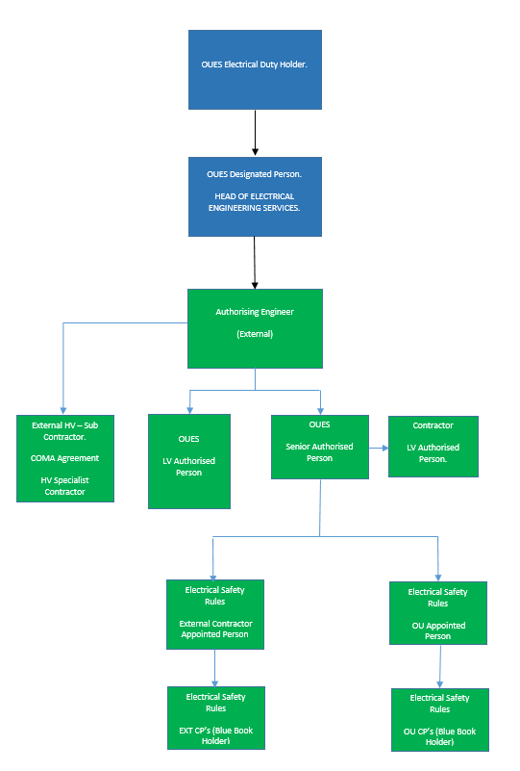

# Definitions

Where these Electrical Safety Rules use abbreviations, these are as follows:

AE stands for Authorising Engineer (Electrical)

SAP stands for Senior Authorised Person (Electrical)

DAP stands for Duty Authorised Person (Electrical)

OU AP stands for University Authorised Person (Electrical)

EXT AP stands for External Authorised Person (Electrical)

PAP stands for Prospective Authorised Person (Electrical)

OU CP stands for University Competent Person (Electrical, Blue Book Holder)

EXT CP stands for External Competent Person (Electrical, Blue Book Holder)

PiC stands for Person in Charge

**Appointed HV Contractor**

A Contractor assessed and appointed by OUES to carry out isolations and maintenance activities on a designated HV electrical network operating under their own approved Electrical Safety Rules.

**Authorised Person’s (Electrical) Key Box**

An approved device with a combination lock to hold securely the DAP’s key.

**Competent Person (Blue Book Holder)**

A person who has been assessed and deemed competent to operate on the University of Oxford fixed wiring system

**Client**

For the scope of these Rules, client means a person or organisation using the services of OUES.

**Complex Low Voltage Network**

Complex systems include incomers from HV/LV transformers, LV Primary Switchboard Bus-Sections, LV Primary Interconnections, sub-main cables from main LV switchpanels, generators, UPS, equipment that is or can be supplied by generators or UPS installations, or where there is the possibility of two sources of supply.

**Confirm Dead**

After the issue of an Electrical Safety Document demonstrate with the use of approved Test Equipment that no electrical potential is present that is liable to cause danger or injury.

**Contractor**

Any person not directly employed by OUES but contracted to OUES to provide goods or services.

**Consultant**

Any person not directly employed by OUES but contracted to design electrical services for OUES.

**Danger**

Means danger to health or danger to life or limb from shock, burn or other injury to persons employed, dependent upon the generation, transformation, distribution or use of electrical energy.

**Dead**

Disconnected from live parts and not electrically charged.

**Electrical Distribution Systems**

The networks of electrical Equipment, transformers, switchgear and cables installed to supply electrical energy to all parts of the site.

**Disconnected**

Isolated and separated from all live parts by an air gap appropriate for the normal operating voltage of that Equipment.

**Earths**

**Earthed** – connected to the general mass of earth in such a manner as will ensure at all times an immediate discharge of electrical energy without danger.

**Temporary Earth** - a connection to earth, applied by an Authorised Person (Electrical) at a position specified in a Permit to Work or Sanction to Test, made before working on or testing Equipment to ensure as far as is practicable that the Equipment does not become electrically charged. It is secured, where practicable, by a Safety Lock. On completion of a Permit to Work or Sanction to Test these earths shall be removed by the Authorised Person (Electrical)

**Removable Temporary Earth** - a proprietary earth, secured by a Working Lock, applied by an Authorised Person (Electrical) working or testing at a position specified on a Sanction to Test which may be removed by the Person in Charge for the duration of the test. These earths are listed on the Sanction to Test by the Authorised Person (Electrical) prior to the issue of the Sanction to Test.

**Electrical Equipment**

Equipment used, intended to be used or installed for use, to generate, provide, transmit, transform, rectify, convert, conduct, distribute, control, store, measure or use electrical energy.

**Electrical Room**

The following definitions are used in these Electrical Safety Rules:

**HV Sub-Station** - An enclosure containing HV distribution equipment, namely switchgear, HV generators or transformers.

**Main LV Switchroom (Complex)** – The main LV switchroom for a site containing an LV switchpanel that has more than one incoming supply, e.g. two incoming LV supplies, or a secondary supply from an electrical generator etc.

**Main LV Switchroom (Non-Complex)** – The main LV switchroom for a site containing an LV switchpanel that has only one incoming supply

**Ancillary Electrical Switchroom** – a room containing electrical plant and equipment, e.g. DRUPS, UPS, generator, battery room etc.

**Electrical Riser Cupboard** – A room or cupboard containing LV distribution switchgear, e.g. sub-main switch panel, fuseboard, MCB board, loose switchgear etc.

**Emergency Switching**

Switching carried out by a person who is competent to isolate electrical supplies in an emergency so as to avoid danger and make safe electrical equipment.

**Employee**

A person directly employed by OUES.

**Employer**

For the scope of these Rules, employer means OUES.

**First Aid**

Emergency care or treatment given to an ill or injured person before regular medical aid can be obtained.

**Functional Testing**

The testing of Electrical Equipment to ensure their correct operation.

**Injury**

Death or injury to persons from electric shock, electric burn, fires of electrical origin, electric arcing or explosions initiated or caused by electricity.

**Isolation**

A switching operation including the fitting of appropriate safety locks and notices, to disconnect and separate by a safe distance any Electrical Equipment, equipment and conductors from all sources of electrical energy, in such a way that the disconnection is secure i.e. it cannot be re-energised accidentally or inadvertently.

**Key Cabinet**

A cabinet for the sole purpose of retaining all keys relative to the site’s HV/LV system(s) to which the Duty Authorised Person (Electrical) has control.

**Live**

Electrical Equipment or equipment that is electrically charged, is still connected to the general electrical distribution system, and has not been verified as DEAD

**Lock Out – Tag Out (LOTO)**

An element of a safe system of working for the isolation of equipment / systems by the Authorised / Competent Person which requires ‘securing’ and ‘tagging’ a Point or Points of Isolation.

**Operational Procedures Manual (Electrical Systems)**

A ring-binder containing information relating to the control and operation of the high and low voltage systems.

**Operations and Maintenance**

The undertaking of the functional actions of the Electrical Equipment on site, and the routine periodic maintenance and inspection of the same Electrical Equipment.

**Operational Restriction**

A Written Instruction, issued by OUES, AE, a manufacturer or a supplier of equipment or system modifying or prohibiting the normal operating procedures associated with a particular type of Equipment or system.

**Personnel**

**Designated Person** - a person appointed by OUES with responsibility for:

* The application, implementation and auditing of these Electrical Safety Rules
* Appointment of the Authorising Engineer
* Approval of variations to these Electrical Safety Rules

**Competent Person (Electrical) (OU CP) (Blue Book holder)** – a person who has sufficient technical knowledge, training and experience to enable him to avoid danger, who has been assessed and appointed by the Senior Authorised Person (Electrical), having authority delegated to him according to his knowledge, training and experience, to carry out specific operations and/or work on specific Electrical Distribution Systems or Equipment.

**External Competent Person (Electrical) (EXT CP) (Blue Book holder)** – a person who has sufficient technical knowledge, training and experience to enable him to avoid danger, who has been assessed and appointed by their Appointed Person, having authority delegated to him according to his knowledge, training and experience, to carry out specific operations and/or work on specific Electrical Distribution Systems or Equipment

**Person in Charge (PiC)** – a Competent Person (Electrical) who has accepted a Permit to Work, a Sanction to Test, a Certificate for Live Working, Standing Instruction, or a Limitation of Access. A Competent Person who understand the works being undertaken and takes responsibility for the safety of all persons undertaking the work and the safety of any persons working under the control PiC.

**Authorised Person (Electrical) (AP)** – Responsible for implementing these Electrical Safety Rules on site. A person who has been adequately trained, assessed and possesses sufficient technical knowledge to enable him to carry out all duties associated with the operation, maintenance and earthing of High Voltage and complex Low Voltage Equipment., maintaining records, maintaining test equipment and PPE.

**External Authorised Person (Electrical) (AP)** – an individual who is not directly employed by the university but has undertaken adequate and familiarity training of the University electrical network who is responsible for implementing these Electrical Safety Rules on site. A person who has been adequately trained, assessed and possesses sufficient technical knowledge to enable him to carry out all duties associated with the operation, maintenance and earthing of High Voltage and complex Low Voltage equipment, maintaining records, maintaining test equipment and PPE.

**Duty Authorised Person (Electrical) (DAP)** – An Authorised Person who has current responsibility for a system or installation as recorded in the Site Logbook (Electrical Systems), and who personally holds or carries the Authorised Person’s key and is the only person who can issue, cancel or withdraw electrical safety documentation.

**Senior Authorised Person (Electrical) (SAP)** – Responsible for implementing these Electrical Safety Rules on site, coordinating the activities of Authorised Persons (Electrical), providing technical assistance to the Authorised Persons (Electrical), maintaining records, maintaining test equipment and PPE, and for appointing Competent Persons (Electrical)

**Prospective Authorised Person (Electrical) (PAP)** - a person nominated for the role of an Authorised Person (Electrical), who is undergoing the required training, mentoring and experience process prior to assessment by the Authorising Engineer (Electrical)

**Authorising Engineer (Electrical) (AE)** – An Authorising Engineer (Electrical) appointed in writing by the Designated Person with responsibilities for assessing Authorised Persons (Electrical) and auditing these Electrical Safety Rules to ensure compliance.

**Accompanying Safety Person -** A person not involved in the work or test, who has received Emergency First Aid Training and who has adequate knowledge, training, experience, and ability, to avoid danger, keep watch, prevent interruption, apply First Aid and summon help. The person is to be familiar with the system or installation being worked on or tested and is to have been instructed on the action to be taken to disconnect the equipment in the event of an accident or incident.

**Appointed Person -** A Senior person with an external company with electrical health and safety responsibilities who has received adequate training to authorise employee’s within the company to work on the university fixed wiring and issue the competent person a Blue Book to the correct level of their knowledge and competency.

**Prove Dead**

Prior to the issue of an Electrical Safety Document, the AP shall demonstrate with the use of approved Test Equipment that no electrical potential liable to cause danger or injury is present.

**Proving Unit**

An approved, calibrated unit specifically designed to verify the function of a high voltage potential indicator or a low voltage test indicator used for verification of DEAD Testing.

**RAMS**

Task-specific Risk Assessment and Method Statement.

**Safety Documents**

**Safety Programme** – a written programme issued by the Duty Authorised Person, setting out and diagrammatically showing the sequence of operations to be followed before a Permit to Work or a Sanction to Test is issued.

**Switching Plan -** a documented plan itemising the actions necessary to alter or normalise the configuration of the electrical distribution network. It is to be used to provide a detailed programme for functional switching or for switching prior to the issue of a Certificate of Isolation and Earthing to allow the system is to be operated safely.

**Isolation and Earthing Diagram -** Before any PTW, STT or CI&E is issued for any HV or Complex LV electrical network, an isolation and earthing diagram shall be prepared. This shall illustrate the safety arrangements that have been implemented at the points-of-isolation and the place of work in order to make the equipment safe for the execution of the work or test.

**Permit to Work (Electrical)** – Written authority issued by the Duty Authorised Person (Electrical) for work to be undertaken on Electrical Equipment

**Sanction to Test -** Written authority issued by the Duty Authorised Person (Electrical) for testing to be undertaken on Electrical Equipment

**Limitation of Access** – Written authority issued by the Duty Authorised Person (Electrical) for specified tasks to be undertaken in an area or location which is under the control of the Authorised Person (Electrical) for electrical safety reasons, and for which a Permit to Work or Sanction to Test are not appropriate

**Certificate for Live Working** – Written authority issued by the Duty Authorised Person (Electrical) and sanctioned by the Authorising Engineer (Electrical) for work or testing to be undertaken on or near live conductors. No work on or near live HV conductors is allowable under any circumstances. Only to be issued in exceptional circumstances for LV circuits where the criteria in the Electricity at Work Regulations can be satisfied and the above sanctions obtained

**Certificate of Isolation and Earthing** – A document issued by the Duty Authorised Person (Electrical) responsible for one side of the demarcation line between two different Electrical Distribution Systems, a to be given to the Responsible Person for the other side of the demarcation boundary, detailing the isolation and temporary earthing operations (where applicable) to be undertaken in order for the work to be undertaken on the Responsible Person’s Electrical Distribution System

**Standing Instruction** – Written authority, applicable for up to three years and reviewed annually, issued by the Senior Authorised Person (Electrical) to an Authorised Person (Electrical) or Competent Person (Electrical) to undertake defined tasks.

**Transfer of System control** – A document completed for handover of live electrical systems or equipment to a Competent Person so that electrical works are carried out under their control and safe systems of work.

**Safety Locks**

Padlocks having only one key, that key is different from all other keys in use on the electrical distribution system. Safety locks shall be indelibly coloured **red**, and each safety lock and its key are to have the same unique serial number for ease of identification. Safety Locks are used for securing the means of isolation. Any lock with more than one key is NOT a Safety Lock.

**Safety Key Box**

Safety Key Box shall have two locks; each lock shall have only one key, one key being labelled “Person in Charge”, and the other key labelled “Duty Authorised Person (Electrical)”. The Safety Key Box locking device shall be so arranged that both locks shall be released before access can be gained to the contents of the Safety Key Box

**Signage**

**Caution Sign** – a temporary, non-metallic sign, used at a point-of-isolation, bearing the words “caution – persons working on equipment” and “do not touch”.

**Danger Sign** –a temporary, non-metallic sign to be used where there is adjacent live equipment at the place of work, bearing the words, “danger live equipment” and “do not touch”.

**High Voltage Enclosure Sign** – A temporary non-metallic sign bearing the words "DANGER High Voltage Enclosure" and "KEEP OUT Authorised Access only".

**Site Logbook (Electrical Systems)**

A hardback or bound book in which all matters relating to the Electrical Distribution System should be recorded.

**Statement of Site Familiarity (Electrical)**

A document completed by an AP to demonstrate adequate knowledge of the electrical distribution for a site for which an extension to his appointment is being sought.

**Switching**

The operation of switchgear, circuit breakers and switch fuses or other methods of breaking or making a circuit.

**Voltage**

The following ranges of voltage are defined as follows:

1. Extra low voltage: a potential not exceeding 50 V ac or 120 V ripple-free dc whether between conductors or to earth;
2. Low voltage (LV): a potential not exceeding 1000 V ac or 1500 V dc between conductors, or 600 V ac or 900 V dc between a conductor and earth;
3. High voltage (HV): a potential normally exceeding low voltage.

**Working Lock**

A padlock that has a unique key and is used to lock electrical equipment in pre-selected positions for operational purposes. The key to these working locks should be held in a key cabinet accessible only to an Authorised Person. The lock and key should be numbered for ease of identification. Red Safety Locks shall not be used for this purpose.

A locks are located on HV Equipment

B locks are located on general LV equipment.

C locks are located on building main switchboard on incoming & bus-section devices.

# Roles and Responsibilities

## Designated Person (Head of Electrical Engineering Services)

The OUES Designated Person’s responsibilities include the following:

* Approval of change mechanisms for these Electrical Safety Rules
* Appointing the Authorising Engineer (Electrical)
* Investigating accidents, incidents, near misses, and implementing appropriate action to avoid reoccurrence
* Communicating learning points from audits, accident and incident reports to operational staff
* Report into the Estates Electrical Duty Holder.
* Induction and Authorisation of the Appointed Person
* Suspension and removal of an Appointed Person, Senior Authorised Person, Authorised Person and Competent persons.

## Authorising Engineer (Electrical) (AE)

* Identifying the number of Authorised Persons (Electrical) required for each site for which the AE (Electrical) are responsible, in order for each site to operate safely and comply with these Electrical Safety Rules.
* Assessing Prospective Authorised Persons (Electrical) and making recommendations for appropriate training.
* Liaison with the OUES Designated Person on Electrical systems safety matters
* Appointment of Authorised Persons (Electrical)
* Carry out annual audits to ensure compliance with these Electrical Safety Rules including the review of the operational experience and ongoing competence of all appointed Authorised Persons (Electrical)
* Providing technical assistance as required
* Where there is a contract or licence / lease between a third party, ensuring that a written agreement is produced, defining the demarcation of responsibilities between the parties involved, for management of Electrical Distribution Systems
* Ensuring that all Accidents, Incidents or Dangerous Occurrence associated with work on Electrical Distribution Systems, are immediately notified to the OUES Designated Person
* Investigating all reported Accidents, Incidents and Dangerous Occurrences
* Providing general advice to Authorised Persons (Electrical) in the execution of their work.
* Approving Certificates for Live Working.
* Counter-signing Safety Programmes and Isolation & Earthing Diagrams produced by an Authorised Person (Electrical)

## Authorised Person (Electrical) (AP)

There are three levels of Authorised Person (Electrical):

* Senior Authorised Person (Electrical)
* Duty Authorised Person (Electrical)
* Authorised Person (Electrical)

A Prospective Authorised Person (Electrical) is a person nominated for the role of an Authorised Person (Electrical), who is undergoing the required training, mentoring and experience process prior to assessment by the Authorising Engineer (Electrical).

### Senior Authorised Person (Electrical) (SAP)

The Senior Authorised Person (Electrical) is responsible for the practical implementation and ongoing operation of these Electrical Safety Rules on all sites, systems, and installations for which OUES has control of the danger, and for which the Senior Authorised Person (Electrical) has been appointed. In addition to general Authorised Person (Electrical) duties and Duty Authorised Person (Electrical) duties (when assuming this role) the Senior Authorised Person (Electrical) shall:

* Assess, appoint and audit appointed Persons (Electrical)
* Assess, appoint and audit OU Competent Persons (Electrical)
* Maintain a register of Competent Persons (Electrical)
* Have overall managerial responsibility for ensuring that the Site Logbook (Electrical Systems) and Operational Procedures Manual (Electrical Systems) are implemented on each site and that they are kept up to date
* Ensure that each site / Authorised Person (Electrical) is provided with sufficient and suitable safety equipment, signage, locks and PPE as necessary and maintain a register of such equipment
* Assist in the training and mentoring of Prospective Authorised Persons (Electrical)
* Coordinate the activities of Authorised Persons (Electrical)
* Provide technical assistance to the Authorised Persons (Electrical)
* Issue Standing Instructions
* Review and approve any Demarcation of Responsibility
* Countersign Safety Programmes and Earthing & Isolation Diagrams
* Approving and signing Certificates for Live Working
* Ensure that the standard of Safety Documents produced are to the required standards
* Control access into HV Sub-Stations
* Assess competence of external Appointed Persons and control the issue of the Blue Book

The Senior Authorised Person (Electrical) may be responsible for one site, group of sites or a region as defined on his Certificate of Appointment.

### Duty Authorised Person (Electrical) (DAP)

Only one Authorised Person (Electrical) can be the Duty Authorised Person (Electrical) for an electrical installation at any time. The Duty Authorised Person (Electrical) assumes the role by signing on in the Site Logbook (Electrical Systems) and taking possession of the Authorised Person (Electrical) key. Each transfer of responsibility between Duty Authorised Persons (Electrical) is to be recorded in the Site Logbook (Electrical Systems). In addition to general Authorised Person (Electrical) duties the Duty Authorised Person (Electrical) shall:

* Issue, cancel and, where necessary, withdraw Permits to Work, Sanction to Test, Certificates for Live Working, Limitations of Access in accordance with these Electrical Safety Rules
* Issue Certificates of Isolation and Earthing
* Ensure that Site Logbook (Electrical Systems) and Operational Procedures Manual (Electrical Systems) are kept up to date
* Undertake or supervise the spiking of cables
* Ensure the mimic diagram is up to date
* Agree and review any Demarcation of Responsibility
* Control access into HV Sub-Stations

### Authorised Person (Electrical)

Authorised Persons (Electrical) shall:

* Ensure as far as is reasonable and practicable, that all personnel within the site observe and comply with the requirements of these Electrical Safety Rules.
* Inform the Duty Authorised Person (Electrical) or Senior Authorised Person (Electrical) of any:
  + Defects in equipment
  + Dangerous Conditions
  + Dangerous Practices that are observed in the course of the Authorised Person’s (Electrical) duties.
  + Dangerous Occurrences, Accidents or Incidents
* Supervise or undertake cable detection or location work within the geographical area of the Authorised Person’s (Electrical) appointment.
* Ensure that Site Logbook (Electrical Systems) and Operational Procedures Manual (Electrical Systems) are kept up to date
* Control access into HV Sub-Stations
* Where requested by the Senior Authorised Person (Electrical), assist in the training and mentoring of Prospective Authorised Persons (Electrical)

## Person in Charge (PiC)

A Competent Person (Electrical) receives a Permit to Work, a Sanction to Test, a Certificate for Live Working, Standing Instruction, or a Limitation of Access and signs Part 2 of the Safety Control Document to declare that they understand the works to be undertaken, and take responsibility for their safety, the safety of any persons working under their control, and all other persons likely to be affected by the work.

The Person in Charge shall follow the Duty Authorised Person (Electrical)'s instructions and shall only work on the equipment for which the Safety Control Document has been issued. Whilst the Safety Control Document is valid, neither the Person in Charge, nor any person under the direct control of the Person in Charge, shall attempt to undertake any other duties.

Unless it is unavoidable, the Person in Charge is not to leave the place of work until the work or test is completed. If the Person in Charge has to temporarily leave the place of work, the work or test shall be suspended, and adequate safety precautions taken to prevent danger. The work or test is not to be resumed until the Person in Charge has returned to the place of work. Additionally, the Person in Charge shall:

* Directly supervise (or carry out) work on an Electrical Distribution System for which they are in receipt of a Permit to Work/Test
* Be continually present throughout the duration of the works
* Ensure that adequate emergency arrangements are in place before the commencement of work
* Ensure that the contents of the Risk Assessment and Method Statement for the task are communicated to all members of the work team
* Ensure that all necessary safety equipment is available and suitable for use prior to commencement of work
* Ensure that all members of the work team are adequately trained, fit and able to carry out the work required
* Be fully conversant with, and able to ensure compliance with the conditions set out in the Permit to Work/Test and agreed Safety Programme and countersign the Isolation & Earthing Diagram to confirm their understanding
* Ensure that the work carried out is that for which the Permit to Work/Test is valid
* Stop work and withdraw all personnel, tools and equipment, should, for any reason, the conditions of the Safety Programme or Permit to Work/Test cannot be met
* Report to the Duty Authorised Person (Electrical) any accident, dangerous occurrence, defects found or other exceptional incidents occurring during work under the Permit to Work/Test
* Be trained and competent to work on Electrical Distribution Systems

## Competent Persons (Electrical) (CP)

* Work in accordance with these Electrical Safety Rules including Appendix 5 & 6
* Take reasonable care of the health and safety of themselves and of any other person who may be affected by their actions or omissions
* Only use equipment for which they have been trained and in the manner in which they have been trained
* Report to the Person in Charge any defects found in tools and equipment used for the works.
* Only work on the Electrical Distribution Systems for which they have been appointed and as defined on the method statement.
* Be trained and competent to work on Electrical Distribution Systems

## Accompanying Safety Persons

The Accompanying Safety Person is a person, not directly involved in the work or test, who has adequate knowledge, experience, training and ability to recognise danger, keep watch, prevent unauthorised interruption of the work, apply first-aid and summon help. The Accompanying Safety Person shall have received training in emergency first-aid in accordance with these Electrical Safety Rules.

The Accompanying Safety Person is required when:

* Proving Dead/Confirming Dead on HV or Complex LV circuits
* Earthing, other than by a switch or circuit breaker
* Working, Inspecting, Fault Finding or Testing on or near Live conductors
* Testing high voltage equipment
* Spiking a cable
* Working in a high voltage enclosure
* Voltage or phasing tests at high voltage
* Where working or testing in accordance with Table LV2 is to be undertaken on Electrical Equipment for which the means of isolation is not positively identified, an Accompanying Safety Person is to be in attendance until the Equipment has been isolated and proved dead
* Whenever the Authorised Person (Electrical) deems necessary

## Appointed Persons

The Appointed Person is a senior person employed by an external contracting company who has been assessed by the Senior Authorised Person to:

* Assess the competence of the contractors employees to carry out defined duties as a competent person (CP)
* Issue each CP with a Blue Book and maintain a register of these issues
* Liaise with the SAP on all work on the OUES estate

# Demarcation Agreements

## General

Whenever there is a division of responsibilities between the site team and others, the SAP shall issue instructions to other parties, as necessary, in order to prevent danger.

Where a specialist contractor has been appointed under contract or other arrangement by the site team, they should be required to comply with:

1. These Electrical Safety Rules
2. All instructions issued by the AP.

Where there is a demarcation of responsibilities between the site team and others, the SAP shall liaise with the other party (or parties) as necessary to avoid danger and to agree the point of demarcation boundary and the contact details of each party.

Each demarcation of responsibilities shall be recorded in writing and precisely described on a diagram.

Each proposed demarcation of responsibilities shall be approved by the SAP before final agreement with the other party (or parties) involved.

A copy of the demarcation diagram shall be prominently displayed at each sub-station and switchroom under joint control.

One copy of the agreement, including the diagram, shall be sent to the AE, and another copy shall be placed in the site Operational Procedure Manual (Electrical Systems).

Where another organisation transfers control of an Electrical System to the site team for the whole or partial duration of a contract, the appointed site team in control of the Electrical System shall request from the other organisation, details in writing of any known hazards that are present, or may be likely to arise, that could affect safety or business continuity. A copy of these details shall be placed in the Operational Procedure Manual (Electrical Systems) and another copy shall be given to the site team contractor(s), if appointed.

Contractor's staff who are to undertake work or tests on parts of systems or installations for which OUES does not have control of the electrical danger are not required to comply with these Electrical Safety Rules but are to comply with the Statutory Regulations and/or any safety rules and procedures issued by the organisation having control of the electrical danger. Contractor's staff that are to undertake work or tests on parts of systems or installations that may affect the business continuity of the site team, shall liaise with the SAP prior to the commencement of such work.

## Handover

For new work, before the system or installation is accepted from the contractor; the site team shall appoint an AP to liaise with the contractor to ensure that the work is undertaken to the required standard and to gain practical knowledge of such equipment, in order to take responsibility for the new systems or installations when officially handed to the site team for day-to-day operation and maintenance.

## COMA

Where the provision of AP’s for all or part of the electrical distribution network is provided by a third party, a Control, Operation and Maintenance Agreement (COMA) shall be in place between OUES and the third party. Prior to implementation of the COMA, the third party’s Electrical Safety Rules shall be audited / checked by the OUES AE to ensure that the Safety Rules are suitable and fit for purpose. The COMA shall be agreed by the OUES AE, and, as a minimum, shall include the following:

* Exact extent of the network covered by the COMA
* Exact services to be provided by the third party
* Service level agreements (SLAs) in place between OUES and the third party
* Contractual terms and conditions
* Cross reference to the agreed third party Electrical Safety Rules
* Schedule of site-specific AP’s approved to work under the COMA
* Details of the network handover procedure to the third party. A handover form shall be provided to document this procedure
* Details of acceptance procedures, by OUES, from the third party on termination of the COMA. A handover form shall be provided to document this procedure
* Details of storage arrangements for issued and cancelled Safety Control Documents produced by the third party.
* A copy of these Safety Control Documents retained on site in the Operational Procedure Manual (Electrical Systems)
* A record of the third party’s AP attendance on site. by signing the Site Logbook (Electrical Systems)

The AE shall audit the COMA and third party’s Electrical Safety Rules annually to ensure suitability and compliance.

Note: where OUES are to retain control of access into HV substations and LV switchrooms and are to have OUES working locks on HV switchgear then the control element of the above shall be omitted and an Operation and Maintenance Agreement (OMA) implemented

# general precautions

## General

Compliance with these Electrical Safety Rules is mandatory for all persons working on, testing or inspecting Electrical Systems under the control of OUES from their initial specification through the processes of design, installation, commissioning, and operation. Persons responsible for specifying works shall consider the needs of the operators of the systems in order that items of electrical equipment may be accessed and isolated for maintenance purposes. The design shall incorporate adequate isolation points to accommodate safe isolation of the electrical equipment. The design shall also consider the needs of the operator for access with sufficient space between electrical equipment to allow the maintenance work to be undertaken safely. Although on site changes are inevitable, any changes made to the original design by the installer shall maintain adequate working areas around electrical equipment and preserve the ability to access for lock off isolation points. The Project Manager in charge of the works shall ensure that any alterations made on site do not affect the application of these Safety Rules to such works.

## Incidents, Accidents and Dangerous Occurrences

In relation to RIDDOR, an accident is a separate, identifiable, unintended incident, which causes physical injury.

A dangerous occurrence shall be reported to the DAP by CP’s as soon as reasonably practicable.

Under RIDDOR the following are defined as Electrical Dangerous Occurrences:

* Any explosion or fire caused by an electrical short circuit or overload (including those resulting from accidental damage to the electrical plant) which either:
  1. results in the stoppage of the plant involved for more than 24 hours; or
  2. causes a significant risk of death.

The DAP is, without delay or as soon as practicable, to send a preliminary report of the dangerous occurrence to the AE (Electrical) and Designated Person.

The AE shall investigate each dangerous occurrence and issue a report to the Designated Person. The report shall be sufficiently detailed to enable the sequence of events leading to the occurrence to be determined. Where reasonably practicable, the report shall include photographs taken before any items of equipment involved in the dangerous occurrence are disturbed.

The Designated Person will report any incident or accident to the statutory authorities as soon as possible, in accordance with RIDDOR.

## Emergency Situations

The normal rules of First Aid shall apply. Casualties may be treated on site by trained personnel.

Emergency procedures shall be included in the contractor’s method statements and risk assessments and shall typically include:

* Preparations made to forecast emergency situation possibilities with suitable arrangements in place need to cover:
  + Rescue and resuscitation requirements
  + Raising the alarm and rescue
  + Safeguarding the rescuers
  + Fire fighting
  + Control of electrical equipment
  + First aid
  + Emergency services and information that may be required

## Un-manned Sites

Where un-manned sites contain Electrical Distribution Systems and do not have a resident AP, suitable arrangements shall be made for the management of the Electrical systems, including:

* Control of access to sub-stations, switchrooms and electrical cupboards
* The appointment of an AP to manage work on HV or complex LV Electrical Distribution Systems
* The appointment of competent, trained and qualified persons to manage work on radial electrical systems
* Custody of the documents relating to the remote site working

## Management of Visitors

The AP will undertake risk assessments for potential visitor access to area within the site where Electrical Distribution Systems are located. The risk assessment shall determine additional control measures to be taken whilst the visitor is on site.

## Locks, Keys and Key Security

All points of isolation and points of application of earths that are stated on safety documentation shall be locked with a Safety Lock and Caution Sign.

Where it is not possible to secure points of isolation with a Safety Lock then other approved forms of isolation must be applied.

Safety Locks are padlocks indelibly painted red having only one key, each key shall be different from all other keys in use. Each Safety Lock shall be marked with a unique identification number and the safety lock key shall be labelled with the same number.

The Safety Lock keys are to be placed in a Safety Key Box until the safety document has been cleared by the person in Charge of the Work, and cancelled by the Authorised Person.

Safety Key Boxes are secure boxes with two unique locks. Each lock shall have only one key, one key labelled “Safety Key Box - PiC”, and the other key labelled “Safety Key Box - AP”. Both locks on the Safety Key Box must be released before access can be gained to the box. Alternative arrangements for Safety Key Boxes may be utilised where authorised by the AE.

Working locks are the padlocks used to lock electrical equipment in pre-selected positions for operational purposes. If unique padlocks are used, the lock and key should be numbered for ease of identification. Red Safety Locks shall not be used for this purpose.

Working lock keys should be kept in a locked cabinet. The key to this cabinet shall be under the control of the Authorised Person.

Working locks shall not be used for isolations required in safety documents.

Access Keys are keys to locks that control access to sub-stations and switchrooms. Access Keys and locks are to be unique, except where a system of controlled suited locks is installed. Alternatively, electronic access control systems may be utilised.

Access Keys to sub-stations and switchrooms shall be under the control of the DAP. Where electronic access control systems are utilised the issue of access codes or cards shall either be by the DAP or access granted with the authorisation of the DAP.

## Key Registers

Key issue shall be controlled under a Key Register. When issuing or returning a key, Authorised Key signatories must enter in the Register:

1. Details of the key
2. Name and signature of the person receiving the or returning the key
3. Date and time of issue
4. Signature of Authorised Key Signatory
5. Date and time of return.

Key Registers are to be kept in the Operational Procedure Manual (Electrical Systems).

Where electronic access control systems, or other approved methods are utilised to control access to sub-stations and switchrooms it is not necessary to follow the above procedure.

## Lost Safety Key Procedure

Should a safety key be broken or genuinely lost, for example dropped into an inaccessible position, application must be made to the SAP who shall sanction the cutting of the safety lock hasp fixed by the safety key. The reasons for the request shall be recorded in the Site Logbook (Electrical Systems). Checks shall be made to ensure that all Safety Documents issued on the circuit have been cancelled before the safety lock hasp is cut.

## Control of Entry into Electrical Rooms and Enclosures

Persons shall NOT enter any Sub-station, Switchroom belonging to, or under the control of OUES without the proper authority.

All Sub-stations, switchrooms and riser cupboards etc., shall be kept locked.

Entry shall be limited to:

* AE
* APs
* Persons accompanied by AE, APs & CPs
* CPs with specific written authority from the DAP detailed on the CPs Certificate of Appointment, issued by the SAP.
* Persons covered by the written approval of a Limitation of Access or Standing Instruction. Unless specifically deemed otherwise by the DAP, these persons will not have to be accompanied.

Any person authorised to work within the confines of a Sub-station, Switchroom, Riser etc. is responsible for the security of the premises. The access to that room shall be restricted to the members of his working party and be left secure when not in attendance.

## Display of Regulations, Instructions and Signage

Copies of the ‘Electricity at Work Regulations 1989’ and ‘Instructions for the Treatment of Persons Suffering from Electrical Shock' shall be posted in all Substations, Switchrooms, Generator Rooms and other appropriate places.

Access to Switchrooms and Substations shall be restricted, and potential hazards shall be identified to individuals by appropriate placing of signboards to the access and external perimeter of the room, enclosure or location. These shall be in Pictogram format in appropriate colours with supporting text to advise:

* 1. Danger Sign warning of the dangers of electricity.
  2. No entry to the location unless under the control of a Permit to Work / Limitation of Access / Standing Instruction.
  3. Location Name and description e.g. Switchroom or Substation.
  4. Emergency Contact Telephone Number.

The following table shall be used as a guide where posters and signage are to be provided:

| **Item** | **No Off** | **Where to be Fitted** |
| --- | --- | --- |
| Electricity at Work Regulations | As Required | Required in HV Sub-Stations, Main LV Switchrooms |
| Resuscitation | As Required | Required in HV Sub-Stations, Main LV Switchrooms, Generator Rooms, UPS Rooms |
| Single Line Diagram | 1No per room | Required in HV Sub-Stations, Main LV Switchrooms, Generator Rooms, UPS Rooms |
| Danger of Death | As Required | Required on all entrance doors into any room containing HV equipment |
| 400V Warning Signage | As Required | Required on all entrance doors into any room containing LV equipment |
| Excessive Noise Warning Signage | As Required | Required on all entrance doors into any room containing excessive noise generating equipment such as generators, UPS etc |
| Automatic Start Warning signage | As Required | Required on all entrance doors into any room containing equipment which may start without warning such as generators, DRUPS etc |

## Operational Restrictions

An operational restriction is a written safety instruction issued via the AE (Electrical), modifying or prohibiting the normal operating procedures associated with a particular make and type of equipment.

On receipt of an operational restriction, the AP shall:

* 1. Acknowledge the receipt to the AE (Electrical), indicating whether the equipment is included in the records of the local system(s) or installations;
  2. Record the receipt in the Site Logbook (Electrical Systems) and the action taken;
  3. Place a copy signed by each AP in the Operational Procedures Manual (Electrical Systems).

Where the equipment to which the operational restriction refers forms part of the local systems and installations, the AP shall:

1. Place a copy of the operational restriction, signed by each AP, in the operating and maintenance manual;
2. Arrange for any inspection and remedial work required;
3. Where considered necessary, fix warning signs on each item of equipment involved and report the satisfactory completion of any remedial works to the AE Electrical).

## Personal Protective Equipment

OUES has an obligation within the Personal Protective Equipment at Work Regulations 2002 to supply suitable Personal Protective Equipment (PPE).

Employees have the following duties:

* To wear the supplied PPE to protect them from risk,
* To care for their equipment,
* To remove damaged items from service and arrange replacement,
* To carry out and record an annual audit of their PPE.

PPE shall be worn as a control measure as the final protection against residual risk after all other control measures indicated by the risk assessment have been applied.

Contractors shall provide suitable and sufficient PPE to their employees.

# operating records

## Document Cabinet (Electrical Systems)

A lockable Document Cabinet shall be provided for the documents supporting the management arrangements for Electrical Distribution Systems. These documents shall include the following:

* Working pads, completed pads and stocks of all Safety Control Documents
* The Site Logbook (Electrical Systems)
* The Operational Procedure Manual (Electrical Systems)
* Other relevant documents including RAMS etc.

The Document Cabinet is to be a lockable drawer, cabinet or series of cabinets which is to be kept locked when unattended. Access is to be under the control of the APs.

The Document Cabinet, and the documents/information contained therein are, and remain, the property of OUES. Access to the Document Cabinet and its contents shall remain available to OUES following any change of AP, AE or Maintenance Management Organisation.

## Operational Procedure Manual (Electrical Systems)

For each site for which APs have been appointed, a ring-binder file entitled “Operational Procedure Manual (Electrical Systems)” shall be prepared.

The binder shall be clearly and indelibly marked with the name of the site, location, system or installation to which it refers and shall be kept in the Document Cabinet (Electrical Systems) when not in use. Where information is held elsewhere, either in hard copy or electronically, there is no requirement to duplicate however a cross-reference shall be provided under the relevant section below to the location of the information.

The manual shall contain the following information:

* Authorising Engineer Appointment
* Senior Authorised Person (Electrical) Appointment Certificates & Training Records
* Authorised Person (Electrical) Register & Appointment Certificates & Training Records
* Competent Person (Electrical) Register & Appointment Certificates & Training Records
* Accompanying Safety Person Register
* Operational Restrictions Received
* Cancelled Operational Restrictions Plus Work Carried Out
* Register of Standing Instructions
* Safety Documents: Completed PTWs, STT, Safety Programmes, I&ED’s, RAMS
* Limitations of Access: Completed LoAs, RAMS
* Register of Test Equipment & PPE
* Demarcation of Responsibility Agreements
* Audit Records
* Key Issue Register

For sites without permanent Authorised Persons an abridged manual may be implemented containing the following information provided that full records are held in a central location:

* Authorising Engineer Name
* Senior Authorised Person Register
* Authorised Person Register
* Competent Person Register
* Safety Accompanying Person Register
* Operational Restrictions Received, Cancelled Plus Work Carried Out
* Register of Standing Instructions
* Completed Safety Documents
* Risk Assessment and Method Statement for the actual task carried out
* Demarcation of Responsibility Agreements

File copies of Safety Control Documents shall be retained in the Document Cabinet (Electrical Systems) for a period of three years after the date of their cancellation or termination.

## Site Logbook (Electrical Systems)

The site logbook is kept on the Electrical Services Team channel stored in the document folder as Authorised Person Information. Hard copy of switching schedules, Electrical Safety Plans, Permit to Works and Limitation of access are kept in A4 Ring binders in the Electrical Services Team office at The Malthouse.

Signature Entries shall be made in chronological order, and shall show:

* An operation or a sequence of operations of HV switchgear and/or main LV distribution switchgear. Where this is detailed on a Switching Plan it is not necessary to detail all switching operations, however a cross-reference to the relevant Switching Plan shall be made.
* The completion of switching operations as detailed on a Safety Programme including the serial number of the Safety Programme, building, area, purpose of the switching operations and equipment made safe;
* Adjustment of the Mimic Diagram to indicate the present state of the system or installation;
* The issue and return of a switchroom master key (Note where electronic access systems are utilised this section is not relevant);
* The transfer and acceptance of responsibility between DAPs;
* The issue of any Standing Instruction;
* The issue and cancellation of all Electrical Safety Documents e.g. Permits to Work or Sanctions to Test, or of Live Working Certificates;
* The withdrawal of an Electrical Safety Document e.g. Permits to Work or Sanctions to Test, or of Live Working Certificates, the reason and the action taken;
* The receipt and termination of an Operational Restriction;
* The loss of a Permit or Sanction;
* All unplanned events affecting the electrical network such as power failure, equipment failure etc.

The layout of the Site Logbook (Electrical Systems) shall be as below:

|  |  |  |  |  |  |
| --- | --- | --- | --- | --- | --- |
| **Date** | **Time** | **Location** | **Identity of Equipment or Circuit** | **Event or Operation and Reason** | **Initial of AP** |
|  |  |  |  |  |  |

Completed Site Logbook (Electrical Systems) shall be retained in the Document Cabinet (Electrical Systems) for a period of three years after the date of the last entry.

# Operating Procedures

## Risk Assessments

Prior to any work on an Electrical Distribution System a ‘suitable and sufficient’ Risk Assessment must be produced together with task specific Method Statements (RAMS) for the proposed works.

The AP shall review the risk assessments prior to the issue of a Safety Control Document. There must be a reasonable time-frame prior to the requirement for a Safety Document to enable the AP sufficient time to review the RAMS.

Ideally a minimum of 3 working days written notice is required. This time-frame is important in order for the:

* AP to appraise the RAMS
* Inform departments likely to be affected by the proposed works
* Ensure that the works do not conflict with other planned activities
* Ensure that an AP will be available for the planned works to issue Safety Control Documents.

The AP shall review the RAMS and determine if it is adequate. Should the AP consider that the RAMS are inadequate a Safety Control Document shall not be issued.

The RAMS shall be retained within the Safety Document Cabinet

## Safety Documents

There are nine electrical Safety Control Documents issued by APs for working on electrical systems:

* Safety Programme
* Switching Plan
* Isolation and Earthing Diagram (I&ED)
* Limitation of Access (LoA)
* Permit to Work (Electrical) (PTW)
* Sanction to Test (STT)
* Certificate of Isolation & Earthing (CI&E)
* Certificate for Live Working (CLW)
* Standing Instruction (SI)

## Safety Programme

Before any PTW, STT or CI&E is issued for any HV or Complex LV electrical network, a safety programme, detailing the intended sequence of safety operations to be performed to make the equipment safe for the execution of the work or test, shall be prepared.

### Contents of Safety Programmes

The safety programme shall be completed by the AP Electrical who shall be responsible for issuing the PTW, STT or CI&E. The safety programme shall indicate:

1. The name, signature and location of the originating AP(Electrical)
2. The name, signature and location of the countersigning AP (Electrical)
3. The name, signature and location of the countersigning AE (Electrical) where applicable
4. The date the countersigned programme shall commence
5. The purpose of the proposed work or test
6. The equipment that the proposed sequence of operations will make safe for the work or test to be undertaken
7. The sequence of operations to be undertaken up to, and including, the issue of a PTW, STT or CI&E
8. The location, including any name and identification code, at which each operation shall be performed
9. The identity of each item of switchgear to be operated (the identity as stated on the local equipment label)
10. The operation to be performed and the reason for the operation
11. Any “items required” (for example keys, locks, safety signs, protective equipment, handles, documents etc.)
12. The requirement for an Accompanying Safety Person for a specific operation
13. All intended special instructions or safety measures to be included on the PTW, STT or CI&E
14. Confirmation, where applicable, that prior notification has been given to persons and or departments, who will be affected by the proposed operations, and that contingency plans, where required for critical areas, can be implemented in an emergency
15. Receipt of a safety document from another party (e.g. receipt of a Certificate of Isolation and Earthing from a DNO)
16. The sequence of operations to be undertaken to restore supplies after the PTW, STT or CI&E has been cancelled

Safety programmes shall be written in the present tense, e.g. “Switch to OFF”.

When a safety programme has been completed, it shall be countersigned by another AP (Electrical) who has detailed working knowledge of the particular system involved.

### Implementing Safety Programmes

Before commencing the sequence of operations detailed on the countersigned safety programme, the DAP shall confirm that the person(s) responsible for the day-to-day operational management of the areas to be affected by the intended work or test are fully aware of the impact the proposed work will have on the electrical supplies to the affected area.

Before commencing the sequence of operations detailed on the countersigned safety programme, the duplicate shall be placed in the Operational Procedure Manual (Electrical Systems).

The DAP shall refer to the safety programme whilst carrying out the sequence of operations detailed on the safety programme and shall note the date and time of each switching operation.

The serial number of the isolation and earthing diagram and permit or sanction shall be entered on the safety programme as a cross-reference.

### Completion of Safety Programmes

On completion of the sequence of operations detailed on the safety programme, a summary shall be entered in the Site Logbook (Electrical Systems). This summary shall include the safety programme serial number, start and finish times, and reason for the operation.

On completion safety programme shall be retained in the Operational Procedure Manual (Electrical Systems).

## Isolation and Earthing Diagram (I&ED)

Before any PTW, STT or CI&E is issued for any HV or Complex LV electrical network, an isolation and earthing diagram shall be prepared. This shall illustrate the safety arrangements that have been implemented at the points-of-isolation and the place of work in order to make the equipment safe for the execution of the work or test.

An isolation and earthing diagram shall show:

1. The name, signature and location of the originating AP;
2. The name, signature and location of the countersigning AP;
3. The date the countersigned programme is to commence;
4. The purpose of the proposed work or test;
5. The equipment that the proposed sequence of operations will make safe for the work or test to be undertaken;
6. The cables and equipment to be worked on or tested;
7. The points-of-isolation;
8. The points-of-earthing;
9. The points-of-work or test;
10. All safety locks and signs fitted.

Isolation and earthing diagrams shall be written in the past tense, e.g. “Switched to OFF”.

### Implementing the Isolation and Earthing Diagram (I&ED)

The DAP shall note the serial numbers of the safety programme, PTW or CI&E to enable the documents to be cross-referenced.

The DAP shall show the isolation and earthing diagram to the PiC indicating the safety arrangements at the points-of-isolation and earthing, and at the point(s) of the work or test. The PiC shall sign the isolation and earthing diagram to indicate an understanding of the safety arrangements in place.

The isolation and earthing diagram shall be attached to the PTW, STT or CI&E before issue of the PTW, STT or CI&E.

### Completion of the Work or Test

On completion, the isolation and earthing diagram shall be filed in the Operational Procedure Manual (Electrical Systems).

## Switching Plan

A switching plan is defined as a documented plan itemising the actions necessary to change the configuration of an electrical distribution network. The switching plan shall be used to provide a detailed programme for complex functional switching to allow the electrical system to be operated safely.

## Permit to Work (Electrical) (PTW)

A Permit to Work (PTW) is a written authority issued by the DAP to a PiC for work to be undertaken on High Voltage; or complex Low Voltage equipment; or where the DAP deems necessary.

It is specifically used to identify to the PiC:

1. The equipment on which it is safe to work
2. Where isolations have been made
3. Where earths have been applied
4. The work to be done
5. Any special instructions required by the issuing DAP.

The PTW shall be visibly displayed at the point of work throughout the duration of the work.

A PTW can only be issued to PiCs or another AP (an AP cannot issue a PTW to himself).

### Issue, Acceptance and Cancellation of Permits to Work

A Permit to Work shall be issued at the point of work.

The issue and cancellation of every PTW is to be recorded in the Site Logbook (Electrical Systems).

The AP shall obtain appropriate client permissions before any service is isolated.

Before the issue of a PTW the DAP is to demonstrate to the PIC:

* The identity of the Electrical Distribution System and the component parts to be worked on
* That the Electrical Distribution System or component part has been isolated
* The safety arrangements at the place of work and at points of isolation
* Any special instructions and/or safety measures

Before the issue of a PTW the DAP shall ensure that the PIC is in possession of and understands the Task Risk Assessment and the Method Statement for the task.

Before accepting the PTW the PIC shall:

* Read the PTW and the Safety Programme
* Understand the extent of the work
* Understand the safety precautions
* Be prepared to undertake the work
* Sign the PTW.

The PIC shall sign the relevant Section of the PTW to accept the responsibilities of the PiC. On signing for acceptance of the PTW the PiC authenticates the permit as valid and becomes the PiC of the permitted work.

The PiC is then to either take control of the PiC key from the Safety Key Box or is to attach a unique padlock to the multi hasp on the Safety Key Box and take control of the key to that padlock.

The acceptance of a PTW identifies the PiC as personally responsible for supervising or undertaking the defined work. The PiC retains the original Permit to Work until the task is completed or stopped.

While the work is in progress, the PiC is not permitted to leave the site or to undertake any other work or tests. During any temporary absence of the PiC from the point of work, the work is to be halted. The PiC is to ensure that suitable safety precautions are taken, and the AP informed, before leaving the point of work.

Where a change of PiC is required the PTW is to be closed and a new PTW issued.

### Completion of the Work

On completion of the work the PiC shall:

* Withdraw all persons, equipment, tools and instruments from the point of work
* Advise all persons under his or her control that they are no longer permitted to work on the electrical system
* Complete and sign the relevant section of the original PTW
* Return the original PTW to the DAP
* Return the PiC Key or remove the unique padlock from the multi hasp.

The DAP is to confirm that the work has been completed satisfactorily.

The DAP is to close the PTW by signing the original.

If the DAP decides that it is necessary to stop the work, the PTW shall be withdrawn and cancelled. The withdrawal shall be noted on the original PTW and the reasons for withdrawal and any actions taken are shall be noted in the Site Logbook (Electrical Systems). A new PTW shall be issued before re-starting work.

Where the work is stopped, the PTW shall be cancelled. The PiC shall:

* Withdraw all persons and if appropriate all equipment, tools and instruments from the place of work
* Advise all persons under his control that they are not permitted to work on the system
* Amend the relevant Section of the original PTW to highlight that the work is incomplete, and the point of work has been made safe
* Return the original PTW to the DAP
* Return the PiC Key or remove the unique padlock from the multi hasp.

## Standing Instruction

A Standing Instruction (SI) is a written authority originated by the SAP, valid for a maximum period of three years. The SI shall be reviewed annually by the SAP.

The Standing Instruction shall be issued by the SAP to a PiC to undertake defined, routine tasks.

The SAP may originate a Standing Instruction for:

* Defined tasks on Low Voltage systems or installations,
* Inspection, fault finding and testing of Equipment on Low Voltage systems
* Inspection, fault finding, testing and topping-up on battery installations, with a terminal voltage not exceeding 120V
* Defined switching operations, in respect of specific items of High Voltage Equipment and Low Voltage Distribution Equipment, where the defined operations do not give rise to the need to issue a Sanction to Test, Permit to Work, or Certificate of Isolation and Earthing
* Low risk, routine tasks (such as emergency lighting inspections, fire alarm tests, fire extinguisher tests, rodent trap inspections etc) within a potentially high-risk environment i.e. HV sub-stations, main LV switchrooms, Generator / UPS / Battery rooms

The PiC to whom the SI is issued shall have received appropriate training for the tasks to be undertaken. The training records shall be retained in the CP register in the Operational Procedure Manual (Electrical Systems).

Method statements, risk assessments, switching schedules, safety programmes as necessary shall be provided prior to the issue of a Standing Instruction. The AP and PiC shall sign the Standing Instruction:

* The original Standing Instruction shall be retained by the PiC
* The duplicate Standing Instruction together with all associated safety documentation e.g. RAMS etc., shall be filed in the Operational Procedure Manual (Electrical Systems) and the Schedule of Standing Instructions completed
* The issue of a Standing Instruction shall be recorded in the Site Logbook (Electrical Systems)

An AP may, at any time, cancel a Standing Instruction by retrieving the original from the PiC. The cancellation is to be notified to the SAP.

On termination, the original of the Standing Instruction shall be retained and filed in the Operational Procedure Manual (Electrical Systems). Both the original and the duplicate are to be overwritten with the word, “CANCELLED” or “EXPIRED”, as appropriate, followed by the date of termination and retained in the Operational Procedure Manual (Electrical Systems) for three years following the date of termination.

The cancellation or expiry of a Standing Instruction shall be noted in the Site Logbook (Electrical Systems).

The SAP shall review the Standing Instruction at a period not exceeding one year, in order to ensure that the site conditions or risks involved in undertaking the task defined within the scope of the Standing Instruction, remain unchanged. This review shall be recorded in the Site Logbook (Electrical Systems).

When an AP is appointed they are to review all existing Standing Instructions and familiarise him/herself with the contents of the existing Standing Instructions and associated Risk Assessments and Method Statement for the tasks.

## Sanction to Test (STT)

A Sanction to Test (STT) shall be issued by an AP to a PiC before testing of HV equipment and cables. The procedure for issue, acceptance and cancelling a STT follows the same procedures outlined in the PTW section.

In addition, the STT shall detail the positions of all Removable Temporary Earths which shall be secured by a Working Lock, applied by the AP, which may be removed by the PiC for the duration of the test and replaced after completion of the tests.

## Limitation of Access (LoA)

A Limitation of Access (LoA) is a safety control document issued by the DAP to a PiC carry out specific work not applicable to other electrical safety documentation, which is to be undertaken in an area or location that is normally locked and under the control of the AP (e.g. switchroom, generator room, UPS room). A LoA may also be used as a means of controlling work undertaken by external contractors around the site.

A LoA shall not be issued for any work requiring an electrical isolation.

The DAP may originate a LoA for:

* Defined tasks on a Low Voltage systems or installations,
* Inspection, fault finding and testing of Equipment on Low Voltage systems
* Inspection, fault finding, testing and topping-up on battery installations, with a terminal voltage not exceeding 120V
* Defined switching operations, in respect of specific items of Low Voltage Distribution Equipment, where the defined operations do not give rise to the need to issue a Permit to Work, or Certificate of Isolation and Earthing
* Low risk tasks (such as emergency lighting inspections, fire alarm tests, fire extinguisher tests, rodent trap inspections, building work etc) within a potentially high-risk environment i.e. HV Sub-Station, main LV switchrooms, Generator / UPS / Battery rooms

The PiC to whom the LoA is issued shall have received appropriate training for the tasks to be undertaken.

A LoA shall be issued at the point of work.

The issue and cancellation of every LoA is to be recorded in the Site Logbook (Electrical Systems).

Before the issue of a LoA the DAP shall ensure that the PiC is in possession of and understands the Task Risk Assessment and the Method Statement for the task.

The PiC shall sign the relevant Section of the LoA to accept the responsibilities of the PiC and shall be personally responsible for supervising or undertaking the defined work. The PiC retains the original LoA until the task is completed or stopped.

## Certificate for Live Working

A Certificate for Live Working shall not be issued for any work at High Voltage.

A Certificate for Live Working shall be issued by the DAP to a PiC before any work on, or near, defined live electrical equipment is started, unless such equipment is operating at extra low voltage and a Risk Assessment indicates that live working presents no danger.

A Certificate for Live Working shall be signed by a representative of the Client approving the requirement for live working. Note: where the equipment to be worked on is under the control of OUES, the Designated Person, or his nominated representative shall sign the Certificate for Live Working acting as the Client thereby approving the requirement for live working.

Prior to any live work commencing, endorsement for such work must be obtained from the Authorising Engineer (Electrical) in the form of a letter, email or other media. A cross-reference to this endorsement shall be entered on the Certificate for Live Working by the SAP.

A Certificate for Live Working shall be signed by the SAP approving the requirement for live working.

An Accompanying Safety Person shall be present at the point of work for the duration of the activity. The ASP shall sign the Certificate for Live Working acknowledging his role and duties.

Before issuing a Certificate for Live Working and starting work on a system or equipment, the DAP responsible for its issue shall be satisfied that:

* 1. It is unreasonable in all the circumstances for it to be made dead;
  2. It is reasonable in all circumstances for work to be carried out on or near it while it is live;
  3. Suitable precautions (including, where necessary, the provision of suitable protective equipment) are taken to prevent injury.

Before issuing a Certificate for Live Working, the DAP should:

1. Determine the actions and precautions necessary to comply with the above requirements, and document them on the certificate;
2. Ensure that the PiC to whom the certificate will be issued fully understands the details of the work to be done;
3. Record in the Site Logbook (Electrical Systems) details of the precautions taken to comply with the requirements.

### Procedure for Issue of a Certificate for Live Working

The following procedures apply to the issue of a Certificate for Live Working:

1. The AP shall enter on the Certificate for Live Working details of the work to be done and precautions necessary. The accuracy and completeness of the certificate shall be agreed with the PiC responsible for carrying out the work;
2. The Client, SAP and ASP shall complete and sign the relevant sections;
3. The original of the certificate shall be issued to the PiC, who, after reading its contents and signifying to the AP that the instructions etc. are fully understood, shall acknowledge the receipt of the Certificate for Live Working by signing the relevant section;
4. The PiC shall retain possession of the original at all times while the work detailed on the certificate is carried out;
5. If, during the course of the work, it is found necessary to change the scope of the work, the Certificate for Live Working shall be returned to the DAP and cancelled. The requirement for live working procedures shall be reviewed and, if still found essential, a new Certificate for Live Working shall be issued clearly detailing the revised work;
6. A Certificate for Live Working shall NOT to be issued for work on any item of equipment or area that is already the subject of a LoA, PTW or STT;

### Procedure for Cancelling a Certificate for Live Working

When work for which a Certificate has been issued is suspended or completed, the PiC to whom it was issued shall sign the relevant section on the Certificate for Live Working and return the Certificate for Live Working to the DAP, who shall cancel the Certificate for Live Working by signing the relevant section and destroying the original Certificate for Live Working, in the presence of the PiC.

## Certificate of Isolation & Earthing (CI&E)

A Certificate of Isolation and Earthing (CI&E) is a formal statement to be completed by a responsible person, such as an Authorised Person, responsible for one side of a demarcation line between two different electrical systems to enable work to be undertaken on an electrical system that is the responsibility of another responsible person. The CI&E is issued by the controlling Authority across the boundary.

A CI&E shall not be used where either a PTW or STT are appropriate.

A CI&E can be used for both HV and LV systems. The following examples show where a CI&E shall be used:

1. The OUES DAP requires the DNO to isolate and, where required, earth the supply to a main incoming HV or LV switchpanel. This may for example require the DNO to isolate and earth the incoming HV cable to the site, or, for LV the DNO removing fuses from their cut-outs. The CI&E is to be issued by the DNO using their standard document.
2. The DNO requires the load end of the incoming supply to the site to be isolated to enable the DNO to underwork on their equipment feeding the site. For example, in the event of a fault on the incoming supply cable which is under the ownership of the DNO the cable will require to be isolated (and earthed if HV) at either end. The OUES DAP shall isolate the incoming equipment under his control and issue a CI&E to the DNO
3. The OUES DAP is requested to isolate and, where required, earth an electrical supply to a third party connected to the electrical network under the control of the DAP. Examples are:
   1. OUES provide a HV supply to a third party from their HV switchpanel with electrical equipment downstream under the control of the third party. Where requested the OUES DAP shall isolate and earth the HV cable to the third party and issue a CI&E, for example to allow the third party to undertake maintenance on their transformer. Control of the maintenance activity will be the responsibility of the third parties AP (or equivalent)
   2. OUES provide an LV supply to a third party from their LV electrical network. For example, in a multi-storey office block tenants are supplied via rising busbars with tap-offs under the control of OUES. If the tenant requires to fit-out their area they may request the OUES DAP to isolate supplies from the tap-off. The OUES DAP shall isolate supplies and fit a safety lock to the tap-off and issue a CI&E (the third parties AP (or equivalent) may require to also fit their own safety lock). All sections referring to earthing shall be marked “N/A”
4. A Risk Assessment deems it necessary to isolate and, where required, earth electrical equipment to facilitate work in the vicinity of electrical services.

When a CI&E is used solely for isolation with no earths being applied the sections with reference to the application of the ‘Earth’ are to be deleted and initialled by the issuing Authorised Person.

### Implementation of Certificate of Isolation and Earthing

For all HV and complex LV supplies a Safety Programme is to be prepared prior to the issue of the CI&E.

For radial LV supplies only, a Safety Programme is not required.

A CI&E is to be issued to the Authorised Person (or the responsible person when the receiving organisation does not have formal ‘Permit to Work’ procedures) responsible for undertaking the Work on the other side of a line of demarcation, detailing the isolation and earthing operations undertaken by the issuing Authorised Person.

The recipient of the CI&E is to acknowledge receipt by signing the original and duplicate. The signature renders the CI&E valid for the period of the work. The original of the CI&E is issued to the receiving Authorised Person, or responsible person, who thereafter takes responsibility for carrying out the work.

The issue or receipt of a CI&E and details of the Safety Programme (where applicable) associated with the issue of a CI&E are to be recorded in the Site Logbook (Electrical Systems).

The duplicate of the signed CI&E is to be retained by the issuing Authorised Person and placed in the Electrical Safety Documents Register, until the work is completed and the original returned.

### Completion of Certificate of Isolation and Earthing

On completion of the Work requiring the CI&E and to confirm the cancellation of all associated Permits to Work and Sanctions To Test; and the removal of all persons under the control of the recipient including associated tools and equipment the recipient is to sign Part 3 of the form ‘Clearance’, and return the original CI&E to the OUES DAP immediately and without any intentional delay.

The OUES DAP shall satisfy himself that work has been completed satisfactorily and that any test certificates required are provided to him and shall then sign Part 4 of the form cancelling the CI&E and then restore the network as detailed of the Safety Programme where applicable.

The original is to be retained in the Operational Procedure Manual (Electrical Systems) for three years from the date of issue, the duplicate may then be destroyed

## Statement of Site Familiarity (Electrical) (SoSF)

A Statement of Site Familiarity (Electrical) shall be completed by an Authorised Person (Electrical) where an extension to his appointment is required for an additional site. The Statement of Site Familiarity (Electrical) shall be completed by the AP HV/LV to demonstrate that he is familiar with the electrical distribution on a particular site, for which appointment is being sought in sufficient detail for the AE to appoint him for that site. The electrical distribution must be similar to that on a site for which the AP has already been appointed; if not then the AE will need to visit site with the AP for the assessment and completion of this document will not be required.

The AP must demonstrate that he fully understands how to operate switchgear on the proposed site and must append details of how this familiarity has been achieved e.g. by previous operation experience or via specific training.

The AP shall ensure his full understanding of the electrical distribution at the new site prior to the SoSF being submitted to the AE for approval.

### Procedure for issue of a SoSF

1. The AP is to complete the SoSF form to demonstrate that the AP fully understands the proposed appointment.
2. The AP is to issue the completed SoSF to the AE for approval.
3. The AE shall confirm/decline the appointment of the AP for the proposed site or request a site visit with the AP.
4. Should the AP be successfully appointed to the site, the AP shall keep a copy onsite of the following documents:
   * + SoSF
     + Updated copy of their site appointments.

## Common Requirements for Safety Control Documentation

Each page of a Safety Control Document shall bear the same, unique serial number.

Pads of numbered Safety Documents must be used in sequence.

Only one pad of certificates shall be in use on each site for which an AP has been appointed.

A PTW, STT and Certificate for Live Working shall have an original page and a duplicate page for parts 1 and 2 and a single page for parts 3 and 4.

When not in use, Safety Control Documents shall be kept in the Document Cabinet (Electrical Systems).

Duplicate Safety Control Documents shall not be removed from the pad, even when a Safety Control Document is cancelled before issue.

Cancelled original Safety Control Documents, together with their associated RAMS shall be retained in an appropriate folder in the Document Cabinet (Electrical Systems) for a minimum period of three years after the cancellation date.

Where agreed with the AE, the use of electronic media to produce Safety Control Documents will be subject to additional guidelines and criteria which will form appendices to these Electrical Safety Rules.

## Guidelines for the Use of Electronic Safety Documents

It is permissible to produce Safety Documents electronically provided that a strict set of guidelines are adhered to at all times. Production of Safety Documents using an electronic format must be viewed as a means of improving legibility, clarity and consistency only.

It must NOT be viewed as a means of shortening production time or reduction in the effort and input required to produce such documents.

NOTE: The standards of information to be included on all Safety Documents are the same regardless of the medium used for their production.

The Authorised Person producing the Safety Document and the Authorised Person checking and countersigning the Safety Document are responsible for ensuring the accuracy of all documents produced whether this is by hand-produced or by electronically-produced Safety Documents.

The following guidelines apply to Electronic Safety Documents:

1. All Safety Documents shall have a unique serial number following an agreed convention.
2. A register of Safety Documents shall be maintained on each site in the Operational Procedures Manual (Electrical Systems).
3. When producing a new Safety Document, the AP shall use the next available serial number which shall be entered on each page of the electronic document/form.
4. Once completed, the Safety Documents shall be printed by the originating AP who shall check and confirm that they are correct before physically signing the documents.
5. The Safety Documents shall be checked and physically signed by the countersigning AP (or AE).
6. Once a Safety Document has been signed and countersigned, the electronic version shall be saved as a ‘read-only’ version, thereby preventing any further editing. This ‘read-only’ version shall act as the duplicate version of the actual Safety Document and must be saved so that it is retrievable in the future if required. The physically signed version of the Safety Document shall be known as the original.
7. Times and dates of actual switching operations shall be recorded on the Safety Programme.
8. The Isolation & Earthing Diagram form shall be countersigned by the PiC who shall retain the original. A photocopy may be retained by the AP if deemed necessary.
9. The Permit to Work form shall be printed out and be signed by the DAP and by the PiC who shall retain the original. A photocopy may be retained by the AP if deemed necessary.
10. On completion of the work the original of the I&ED and PTW shall be returned to the DAP. On the front page of the PTW the DAP shall clearly write “Cancelled” diagonally across the page to denote that the PTW has been cancelled and that work has been completed.
11. All Safety Documents shall be filed in the Operational Procedures Manual (Electrical Systems).

## Lost or Missing Safety Documents

Control and responsibility of Safety Control Documents rests with the OUES DAP issuing the Safety Control Documents. Safety Control Documents shall NOT be removed from site.

Should the receiver of a Safety Control Document be absent, all work will cease until a replacement PiC is issued with a replacement Safety Control Document for the work being undertaken.

Should the PiC lose either the original PTW, or their copy of the Safety Programme, a new PTW and copy of the agreed Safety Programme shall be issued as soon as possible after discovery of the loss of the Safety Control Document. Re-issue of a new Safety Control Document shall follow the procedures outlined above.

When the work has been stopped due to loss of documentation, the loss shall be recorded by the AP (Electrical) in the Site Logbook (Electrical Systems). Parts 3 and 4 of the duplicate copy shall be defaced with the words, “ORIGINAL COPY OF PERMIT LOST” (or term appropriate to the missing safety document) written in large print diagonally across the face of the Safety Control Document. Parts 3 and 4 of the duplicate Safety Control Document shall be signed by the PiC and the AP respectively, to acknowledge the loss of the Safety Control Document.

# SAFETY PRECAUTIONS FOR WORK ON HIGH VOLTAGE EQUIPMENT

## General

This section shall apply to all HV equipment forming part of the electrical power distribution system.

## Working in Sub-Stations or Switchrooms

A person who is not a Competent Electrical Person shall be accompanied at all times by an Accompanying Safety Person able to render prompt assistance in an emergency, when working in that part of a Substation or Switchroom containing HV equipment, or in any other place set apart for HV equipment.

Only in Approved cases, where no danger can arise in carrying out the work, may the AP allow persons to work unaccompanied. In both cases, a LoA shall be issued for the work. This work will be for cases where Electrical Network Operations shall NOT be undertaken.

## High Voltage Switching

Only the following shall carry out switching operations on HV systems for which OUES has responsibility:

* OUES SAPs
* CPs under supervision of a OUES SAP and holding suitably endorsed Certificates of Appointment
* A Prospective AP under supervision of a OUES SAP, or under supervision of the AE

In an emergency situation only, HV switchgear may be switched off or tripped by any person. Such action must be reported to an AP as soon as possible.

The HV Distribution Systems are under the control of the DAP and switching on these systems shall NOT be undertaken without prior permission of the DAP.

A mimic diagram of the HV Distribution System and main LV switchpanels shall be maintained by the DAP. The diagram shall give a clear indication of the structure and status of the HV/LV network. The format, layout and type of mimic panel shall be approved by the AE (Electrical).

Before carrying out HV switching operations the DAP shall refer to the site mimic diagram to ascertain the status of the Network and produce a Switching Plan (functional switching) to be followed in order to achieve the desired arrangement.

As soon as practically possible following the completion of a switching sequence, the DAP shall ensure that the mimic diagram is amended to reflect the new configuration of the network.

Before any switching is carried out that may affect the Client’s operating departments, the person authorising the switching shall notify the appropriate personnel.

When Switchgear or Equipment shows any signs of distress after operating, the condition shall be reported immediately to the SAP, and the equipment shall be examined before further operation.

The DAP responsible for switching shall record all switching operations carried out on the Distribution Network, by reference to the associated Switching Plan in the Site Logbook (Electrical Systems).

**7.4 Testing at High Voltage**

Where High Voltage tests are to be undertaken on High Voltage Equipment a Sanction to Test is to be issued by the DAP to the PiC who is to be present throughout the duration of the tests.

The areas containing exposed live High Voltage conductors, Test Equipment and any High Voltage connection are to be regarded as High Voltage Enclosures.

An HV Enclosure shall be set up for all testing where live HV conductors are or shall be exposed.

The HV enclosure shall be set up by an AP or CP acting on the instructions of and personally supervised by the AP.

The area shall contain all exposed live HV conductors, test equipment and any HV connection

Unauthorised access to an HV enclosure shall be prevented by, as a minimum, yellow and black striped tape not less than 25mm wide, suspended on posts and by display of HV Enclosure signs.

Entry to an HV Enclosure is restricted and shall only be allowed to:

* The AP
* A CP acting on the instructions of and personally supervised by the AP,
* The PiC when the HV Enclosure is created as part of the test procedure,
* A CP acting on the instructions of and personally supervised by the PiC
* An Accompanying Safety Person in connection with his or her safety role.
* A prospective AP acting on the instructions or personally supervised by the AP when the operation is part of the prospective APs on-site training.

The procedure to be followed for testing at High Voltage is shown below in table HV2.

## Live Voltage and Phasing Tests

Live voltage and phasing tests on HV equipment may be undertaken provided adequate precautions are taken to prevent accidental contact with, and prevent injury from, live HV conductors.

Neither a PTW nor a STT shall be required.

Live voltage and phasing tests on HV equipment shall be undertaken only by the DAP, with assistance if necessary from a CP acting on verbal instructions from the DAP. An Accompanying Safety Person shall be present throughout.

The DAP carrying out live voltage and phasing tests shall record the operations in the Site Logbook (Electrical Systems).

## Work on Multi Panel Switchboards

Where work or testing is to be undertaken on any part of a multi-cubicle switchboard, the compartment to be opened and worked on shall be identified by the AP and the type and means of identification shown to the CP in charge of the work. Danger Signs shall be prominently displayed on the cubicles or compartments adjacent to the part being worked on or tested. If the board has rear access Danger Signs are to be similarly displayed at both the front and rear of the board. Reliance shall not be placed upon the switchboard labelling when identifying parts at the rear of the board. All discrepancies found shall be reported to the SAP and Authorising Engineer (Electrical).

## Withdrawable Equipment

When withdrawable Equipment has been disconnected from all supplies and withdrawn from its normal live position, the conductors shall be discharged to earth, but need not remain connected to earth.

## General Precautions for Work on HV Equipment

Live working on all HV equipment is FORBIDDEN.

No person shall undertake repairs, maintenance, cleaning, alteration or such work, on any part of High Voltage Equipment unless such parts of the Equipment are removed from all sources of electrical energy. The procedure to be followed is shown below in table HV1:

## Table HV1 - Procedures for Work on HV Equipment

|  |  |
| --- | --- |
| Plan | The AP shall obtain the required permission from departments likely to be affected by the works. The AP shall complete a Safety Programme and Isolation and Earthing Diagram |
| Isolate | The AP shall disconnect the equipment to be worked on from all sources of electrical energy.  The AP shall secure the equipment with a Safety Lock and fit Caution Signs. The AP shall fix danger signs on live equipment adjacent to the point-of-work |
| Prove dead | Where practicable, the AP shall “Prove Dead”, using an approved High Voltage Potential Indicator. The High Voltage Potential Indicator shall be tested immediately prior to and following its use to “Prove Dead”. (Prove-Test-Prove, P-T-P). The AP proving dead shall have an Accompanying Safety Person present.  Where appropriate, Prove Dead on the low voltage side of a transformer, LV feeder pillars, LV switchpanels, distribution boards etc. |
| Earth | The AP shall earth conductors at all points-of-isolation and fix safety locks to earths.  The AP shall identify with certainty, or spike underground cables at the point/s of work if the conductors are to be cut or exposed.  The AP shall earth overhead lines near the working places. |
| Issue a Permit to Work | The AP shall show the PiC the safety arrangements at all the points of isolation and at the locations of the work. The AP shall initial the Safety Programme at each stage as the work proceeds.  The AP shall mark the point-of-work.  The AP shall issue, the Permit to Work, Isolation and Earthing Diagram, and the key to the safety key box, to the PiC.  The AP shall adjust the mimic diagram and complete the Site Logbook (Electrical Systems) to reflect the work undertaken and the current status of the network. |
| Confirm Dead | Where conductors are to be exposed as part of the work and it is not practicable to Prove Dead:  The AP shall remain with, and supervise the PiC until the conductors have been made accessible to test with High Voltage Potential Indicator.  The AP shall confirm the equipment dead to the satisfaction of the Person in Charge. For work on a transformer, the equipment must be Confirmed Dead on both HV and LV windings. The AP confirming dead shall have an Accompanying Safety Person present. |
| Undertake the Work | The PiC shall undertake or directly supervise the work and on completion, or when the work is stopped and made safe, shall return the original of the Permit to Work, the Isolation and Earthing Diagram and the PiC key to the safety key box, to the DAP, and complete part 3 of the PTW. |
| Check the Equipment | If the work has been completed, the AP and PiC shall check to ensure that it is safe to re-energise the equipment. If the work has been stopped, the AP and PiC shall check that the equipment has been made safe. |
| Cancel the Permit to Work | The AP shall cancel the Permit to Work by signing part 4  The AP shall return the key to the safety key box to the key safe. |
| Restoration | The Safety Programme shall include all steps necessary to restore supplies  If the equipment requires testing, the procedures for testing shall be followed.  The AP shall remove safety locks, signs and earths.  The AP shall restore equipment to an operational state.  The AP shall adjust the mimic and complete Site Logbook (Electrical Systems)  The AP shall file the signed Safety Programme, Isolation and Earthing Diagram, and Permit to Work in the Operational Procedure Manual (Electrical Systems). |

## Table HV2 - Procedures for Testing on HV Equipment

|  |  |
| --- | --- |
| Plan | The AP shall obtain the required permission from departments likely to be affected by the works. The AP shall complete a Safety Programme and Isolation and Earthing Diagram |
| Isolate | The AP shall disconnect the equipment to be worked on from all sources of electrical energy.  The AP shall secure the equipment with a Safety Lock and fit Caution Signs. The AP shall fix danger signs on live equipment adjacent to the point-of-work |
| Prove dead | Where practicable, the AP shall “Prove Dead”, using an approved High Voltage Potential Indicator. The High Voltage Potential Indicator shall be tested immediately prior to and following its use to “Prove Dead”. (Prove-Test-Prove, P-T-P). The AP proving dead shall have an Accompanying Safety Person present.  Where appropriate, Prove Dead on the low voltage side of a transformer, LV feeder pillars, LV switchpanels, distribution boards etc. |
| Earth | The AP shall earth conductors at all points-of-isolation and fix safety locks to Temporary Earths and padlocks to Removable Temporary Earths.  The AP shall identify with certainty or spike underground cables at the point/s of work if the conductors are to be cut or exposed.  The AP shall earth overhead lines near the working places. |
| Issue a Sanction to Test | The AP shall show the PiC the safety arrangements at all points of isolation and at the locations of the test.  If a High Voltage Enclosure is to be set up, the AP shall fix High Voltage Enclosure Signs and barriers.  The AP shall mark the point-of test  The AP shall issue the Sanction to Test, Isolation and Earthing Diagram, and the key to the safety key box, to the PiC.  The AP shall adjust the mimic diagram and complete the Site Logbook (Electrical Systems) to reflect the current status of the network. |
| Confirm Dead | Where conductors are to be exposed as part of the work and it is not practicable to Prove Dead:  The AP shall remain with, and supervise the PiC until the conductors have been made accessible to test with High Voltage Potential Indicator, and the AP shall confirm the equipment dead to the satisfaction of the Person in Charge. For work on transformers the equipment must be Confirmed Dead on both HV and LV windings. The AP confirming dead shall have an Accompanying Safety Person present. |
| Undertake the Test | The PiC shall undertake or directly supervise the test, including the disconnection of any Temporary Earths. The PiC, on completion, or when the test is stopped and made safe, shall return the original of the Sanction to Test, the Isolation and Earthing Diagram and the PiC key to the safety key box, to the DAP, and complete part 3 of the Sanction to Test. |
| Check Test | When the test has been completed, the AP and PiC shall, check that the result is satisfactory, that the Equipment has been restored to working order and that it may be safely energised If the test has been stopped, and the AP and PiC shall check that the equipment has been made safe. |
| Cancel the Sanction to Test | The AP shall cancel the Sanction to Test by signing part 4  The AP shall return the key to the safety key box to the key safe. |
| Restoration | The Safety Programme shall include all steps necessary to restore supplies  The AP shall remove safety locks, signs and earths.  The AP shall restore equipment to an operational state.  The AP shall adjust mimic and complete Site Logbook (Electrical Systems)  The AP shall file the signed Safety Programme, Isolation and Earthing Diagram, and Sanction to Test in the Operational Procedure Manual (Electrical Systems). |

# SAFETY PRECAUTIONS FOR WORK ON LOW VOLTAGE EQUIPMENT

## Switching Operations on Complex Low Voltage Distribution Systems

Only APs, or a CP under supervision of an AP, shall carry out switching operations on energised, Complex Low Voltage Distribution Systems.

Complex Low Voltage Systems include incomers from HV/LV transformers, LV Primary Switchboard Bus-Sections, LV Primary Interconnections, sub-main cables from main LV switchpanels, equipment that is or can be supplied by generators or UPS installations, or where there is the possibility of two sources of supply.

## General Precautions for Work on LV Equipment

All work shall be carried out in accordance with HSE Guidance document HSG85 Electricity at Work Safe working practices.

All isolations on complex LV systems shall be carried out by the DAP, under a Safety Programme and I&ED, who shall issue a PTW. The procedures in Table LV1 shall be followed.

In an emergency situation only, LV switchgear may be switched off or tripped by any person. Such action must be reported to an AP as soon as possible.

All isolations on radial circuit from main LV switchpanels and sub-main LV switchpanels shall be carried out by the DAP who shall issue a PTW. Safety Programs and I&EDs are generally not necessary but may be produced by the DAP if required. The procedures in Table LV2 shall be followed.

For radial circuit isolations on final circuit distribution boards or via a local isolator to individual items of plant / equipment (defined as, an item of fixed electrical equipment having only one source of supply, e.g. a dishwasher, refrigerator, motor, air conditioning unit etc.), the following methods shall be adopted:

1. Where detailed on his Certificate of Appointment an AP or CP may carry out isolations for work to be carried out by himself.
2. Contractors who are acting as the EXT CP for the work shall NOT carry out isolations unless given prior permission by an OUCP and in agreement by the department.
3. Portable appliances where connection is made via a plug are excluded.

The procedures in Table LV2 shall be followed for all above isolations and relevant safety documents issued as detailed above.

### Transfer of System Control (ToSC) Procedure

Handover of the electrical system within a building may be achieved in two ways, formally or informally. For minor works on final circuits such as replacing components, the Contractor can take control of the final circuit as part of the instruction to do the work: this is an informal arrangement for the transfer of control of the system and is given only on the understanding that the Contractor will appoint a competent person who will carry out a risk assessment to ensure that an effective and secure isolation can be achieved on the final circuit. If effective and secure isolation CANNOT be achieved using the devices in the distribution board then control of the distribution board MUST be formally handed over.

Formal handover is achieved using the Transfer of System Control Certificate issued by the OUES Senior Authorised or CP14 Person to the Competent Person appointed by the Contractor. The removal of covers that expose conductive parts MUST NOT be removed until the system has been formally handed over AND an effective and secure isolation achieved.

Upon receipt of a Transfer of Control Certificate the Competent Person shall immediately attach caution signs to all Points of Isolation that are under the Contractors control. The Control notice shall identify the Contractor and the appointed Competent Person together with details of an effective method of control, with 24-hour availability, for call out in the event of an emergency. The contractor shall date stamp the caution notice at date of Transfer issue.

## Table LV1 - Procedures for Work on Complex LV Equipment

|  |  |
| --- | --- |
| Plan | The AP shall obtain the required permission from departments likely to be affected by the works. The AP shall complete a Safety Programme and Isolation and Earthing Diagram |
| Isolate and Fix Signs | The AP shall disconnect the equipment to be worked on from all sources of electrical energy.  The AP shall secure the equipment with a Safety Lock and fit Caution Signs. The AP shall fix danger signs on live equipment adjacent to the point-of-work |
| Prove Dead | Where practicable, the AP shall “Prove Dead”, using an approved type of voltage indicator. The Voltage Indicator shall be tested immediately prior to and following its use to “Prove Dead”. (Prove-Test-Prove, P-T-P). The AP proving dead shall have an Accompanying Safety Person present. |
| Earth | Where practicable, the AP shall earth conductors at all points-of-isolation and fix safety locks to earths.  The AP shall identify with certainty or spike underground cables at the point/s of work if the conductors are to be cut or exposed. |
| Issue a Permit to Work | The AP shall show the PiC the safety arrangements at all the points of isolation and at the locations of the work.  The AP shall initial the Safety Programme at each stage as the work proceeds.  The AP shall mark the point-of-work.  The AP shall issue the Permit to Work, Isolation and Earthing Diagram, and the key to the safety key box, to the PiC.  The AP shall adjust the mimic diagram and complete the Site Logbook (Electrical Systems). |
| Confirm Dead | Where conductors are to be exposed as part of the work and it was not practicable to Prove Dead:  The AP shall remain with and supervise the PiC until the conductors have been made accessible to a voltage test indicator.  The AP shall confirm the equipment dead to the satisfaction of the PiC. The AP confirming dead shall have an Accompanying Safety Person present. |
| Undertake the Work | The PiC shall undertake or directly supervise the work and on completion, or when the work is stopped and made safe, shall return the original of the Permit to Work, the Isolation and Earthing Diagram and the PiC key to the safety key box, to the DAP, and complete part 3 of the PTW. |
| Check the Work | If the work has been completed, check to ensure it is safe to energise. If the work has been stopped, check the equipment has been made safe. |
| Cancel the Permit to Work | The AP shall cancel the Permit to Work by signing part 4  The AP shall return the key to the safety key box to the key safe. |
| Restoration | The Safety Programme shall include the steps necessary to restore supplies  If the equipment requires testing, follow the procedures for testing.  The AP shall remove safety locks, signs and earths.  The AP shall restore equipment to an operational state.  The AP shall adjust the mimic and complete Site Logbook (Electrical Systems)  The AP shall file the signed Safety Programme, Isolation and Earthing Diagram, and Permit to Work in the Operational Procedure Manual (Electrical Systems). |

## Table LV2 - Procedures For Working on or Testing Non-Complex Low Voltage Equipment or Systems

|  |  |
| --- | --- |
| Plan | Identify circuit to be worked on.  Before any work or testing can begin, obtain the required permission from departments likely to be affected by the works |
| Isolate and Fix Signs | Isolate from every source of supply.  Make equipment safe to work on or test.  Prevent unauthorised connection or operation by fixing Lock-out devices, Safety Locks and Caution Signs at all points of isolation.  Fix Danger Signs on adjacent live equipment at the point-of-work or test. |
| Prove Dead | Ensure that the equipment to be worked on or tested is the equipment that has been isolated.  Where practicable, “Prove Dead”, using an approved type of voltage indicator. The Voltage Indicator shall be tested immediately prior to and following its use to “Prove Dead”. (Prove-Test-Prove, P-T-P). |
| Issue a Safety Document | Where required issue a Safety Document:  Radial circuit from main LV switchpanel – AP to issue Permit to Work  Final circuit radial isolation carried out by a sub-contractor – self-isolation |
| Confirm Dead | Where it was not practicable to prove the equipment dead, the AP or CP, using appropriate tools and Protective equipment where necessary, is to “Confirm Dead” at the places of the work or test as soon as conductors have been made accessible to a Voltage Test Indicator. |
| Undertake Work or Test | Undertake or directly supervise the work or test. |
| Check Work or Test | Check that the work or test has been satisfactorily completed, that the equipment has been restored to working order, and that it may be safely energised. |
| Cancel Safety Document | Cancel the Safety Document where issued |
| Restoration | Remove the signs and locks and restore the equipment to an operational state. |

## Inspection, Fault Finding and Testing of Live LV Equipment

OUES will NOT allow work on Live electrical equipment unless the requirements of The Electricity at Work Regulations 1989 (Regulations 14 a, b, c are completely met). In all cases the decision for live working must be agreed by the DAP, SAP and AE.

Competent Electrical Persons shall only carry out inspection, fault finding and testing with live conductors exposed on LV equipment and distribution systems in accordance with the requirements of HS (G) 85 and with the permission of the SAP.

All live functional testing and work on live LV equipment shall be conducted in accordance with BSEN60529 (IP2X) level of protection.

Work may include:

* All forms of testing, fault-finding or adjustment where practicalities dictate live working is essential;
* The removal and replacement of fuse carriers in final circuits;
* The removal and replacement of plug-in components;
* Basic battery maintenance (cleaning/topping up only);
* Work on battery systems not exceeding 120V.

Account shall be taken of the following;

1. The Electricity at Work Regulations 1989 Regulations 14 a, b, c place stringent control measures on all employers and persons who may consider it necessary to undertake Live Working.
2. In all cases the decision for live inspection or testing shall be made by the DAP, SAP and AE and any works must be conducted with BSEN60529 (IP2X) as a minimum level of protection. Where this level of protection cannot be provided work shall be carried out with all conductors made dead or carried out under a Certificate for Live Working.

Precautions shall ensure that;

1. An Accompanying Safety Person shall be present at all times - where that person can render prompt assistance in an emergency.
2. Approved electrical test equipment, complying with the Health and Safety Executive Guidance Note HSE GS 38, shall be used.
3. Suitable precautions to prevent danger shall be provided including:

* Insulated screens, barriers and mats shall be provided and used as necessary to avoid danger.
* Safety glasses, insulating gloves, arc-flash overalls, visors, balaclavas etc shall be provided and worn as necessary.
* Only approved tools shall be used

The DAP must be satisfied, before use, that all equipment is suitable for the task.

The special tools and equipment used by persons undertaking live functional testing and work on live equipment shall be of an Approved type. These tools shall be inspected and tested periodically in accordance with the manufacturers’ and legislative recommendations. A record of inspection and testing of all special tools used by persons undertaking live functional testing, and work on live equipment, shall be maintained by the SAP.

Job-specific RAMS shall be produced detailing the names, training and experience of those persons actually carrying out the work; the specific requirement and specification for PPE to be used; requirement for, use of and mounting arrangements for any temporary barriers or screens; full details of emergency arrangements including name, training and experience of the Accompanying Safety Person.

## Working On or Near Live Exposed Conductors

OUES will NOT allow work on Live electrical equipment unless the requirements of The Electricity at Work Regulations 1989 (Regulations 14 a, b, c are completely met). In all cases the decision for live working must be agreed by the DAP, SAP and AE.

Work which involves working within touchable distance of, or, handling exposed live conductors at a potential in excess of Extra-Low Voltage but not exceeding 500 volts between conductors shall not take place without the permission of the AE.

No person shall be engaged in any work activity on or near any live conductor (other than one suitably covered with insulating material so as to prevent danger) where danger may arise unless:

1. It is unreasonable in all the circumstances for the conductors to be dead; and
2. It is reasonable in all the circumstances for him to be at work on or near it while it is live; and
3. Suitable precautions (including where necessary the provision of suitable PPE) are taken to prevent injury.

The following procedures shall be adhered to:

* A Certificate for Live Working shall be issued by the DAP
* An Accompanying Safety Person shall be present at all times - where that person can render prompt assistance in an emergency.
* Approved electrical test equipment, complying with the Health and Safety Executive Guidance Note HSEGS 38, shall be used.
* Insulated screens, barriers and mats shall be provided and used as necessary to avoid danger.
* Safety glasses, insulating gloves, arc-flash overalls, visors, balaclavas etc shall be provided and worn as necessary.
* Only approved tools shall be used

The DAP must be satisfied, before use, that all equipment is suitable for the task.

Job-specific RAMS shall be produced detailing the names, training and experience of those persons actually carrying out the work; the specific requirement and specification for PPE to be used; requirement for, use of and mounting arrangements for any temporary barriers or screens; full details of emergency arrangements including name, training and experience of the Accompanying Safety Person.

# SAFETY PRECAUTIONS FOR WORK ON PHOTO VOLTAIC DC SYSTEMS

## Hazards

In addition to the normal hazards associated with Low Voltage Systems other specific hazards exist with Photo Voltaic DC Systems, these are:

* 1. Photo Voltaic (PV) modules produce electricity when exposed to daylight and individual modules cannot be switched off. Hence, unlike most other electrical installation work, the electrical installation of a PV system typically involves working on a Live System, and therefore must meet the requirements of Regulation 14 (Live Working) of the Electricity at Work Regulations 1989.
  2. As current limiting devices, PV module string circuits cannot rely on fuse protection for automatic disconnection of supply under fault conditions, as the short-circuit current is little more than the operating current. Once established, a fault may remain a hazard, perhaps undetected, for a considerable time.
  3. Undetected, fault currents can also develop into a fire hazard. Without fuse protection to clear such faults, protection from this fire hazard can be achieved only by both a good DC system design and a careful installation.
  4. PV presents a unique combination of hazards – due to risk of shock, falling, and simultaneous manual handling difficulty.

Work on Live Photo Voltaic DC Systems unaccompanied is permitted, provided that:

1. That the work is limited to working on the Photo Voltaic String downstream of the Photo Voltaic String terminal control panel in the case of Central Inverter systems, or the String Inverter in the case of String Inverter systems.
2. Adequate precautions are taken by the use of Approved PPE and Approved insulated tools and other safe methods of working.
3. Provisions are in place to cater for lone working.

## Live Working on Photo Voltaic (PV) Systems

Live working on Low Voltage Systems shall only be permitted on Low Voltage Photo Voltaic DC Systems. All other PV systems shall be made dead, except where a Risk Assessment and Method Statement is developed detailing specific work or testing to be carried out live. All procedures for live working shall be approved by the Authorising Engineer (Electrical).

In all cases an Accompanying Safety Person shall be present, and it shall be confirmed before work commences that that an adequate and reliable means of summoning assistance is provided.

Work near simultaneously accessible live PV string positive and negative parts should be avoided where possible. If it is unavoidable to work in any enclosure or situation featuring simultaneously accessible live PV string positive and negative parts, this must be performed either by utilising approved insulating gloves, tools, insulating materials for shrouding purposes and appropriate personal protective equipment or by covering the PV array. When covering PV panels during installation, the covering must be opaque, cover the whole array and be well secured.

Before breaking or making connections on a Photo Voltaic string, the string shall be disconnected from its outgoing circuits by the removal of DC fuses (both positive and negative) or by means of a switch or isolator. This will ensure that the connections are broken or connected under no load conditions. Appropriate PPE shall be worn, and bespoke fuse extractors shall be used.

Note: Covering a PV array can provide a means to prevent the need for live working but is not recommended. In practice this is often difficult due to achieve due the practical problems of keeping the array covered as the installation proceeds and protecting the covering from the effects of the weather.

## Electric Shock Hazards Associated With PV Systems

It is important to note that, despite the precautions detailed in these Electrical Safety Rules, installers or service personnel may still encounter an electric shock hazard.

Always test for the presence of voltage on parts before touching any part of the system.

An electric shock may be experienced from a capacitive discharge – a charge may build up in the PV system due to its distributed capacitance to earth. Such effects are more prevalent in certain types of modules and systems, namely amorphous (thin film) modules with metal frames or steel backing. In such circumstances, appropriate and safe live working practices must be adopted.

An example of where such hazards may be encountered is the case where an installer is seated on earthed metal roof or structure wiring a large PV array. In such circumstances the installer must touch the PV cabling and can get an electric shock to earth. The electric shock voltage will increase with the number of series connected modules. The use of insulated tools and gloves, together with insulating matting to stand or sit on, can mitigate this hazard.

# ELECTRICAL EQUIPMENT & ANCILLARIES

## High Voltage Ring Main Equipment

Equipment that falls into this category is associated with the majority of substations on sites other than Intake switchgear.

Although the term Ring Main Unit (RMU) is more correctly associated with a “single tank” arrangement having two ring switches and a tee-off transformer circuit in a combined tank or vessel, the term may also be applied to extensible switchgear found at many locations, each element of switchgear having its own insulated chamber and connected by an extensible bus-bar arrangement.

In the majority of cases with this type of switchgear arrangement it is impossible to prove or indeed confirm dead on any HV terminations and reliance is usually placed on proving / confirming dead on the LV side of transformers.

Prior to releasing plant (for PTW or STT activities at the place of work), all switches may be placed into the off position and then placed into circuit earth. Unless such equipment is fed through from a busbar end box, this action will also demonstrate equipment is de-energised from all directions.

When carrying out maintenance on an RMU it is good practice to keep one ring switch in the on position (in the direction of any stated circuit earth) which will maintain an earth on the equipment busbars.

Whilst the majority of RMUs are designed for earthing the circuit, there are a number of designs of switchgear that incorporate both circuit and busbar earthing. This equipment has applications at the remote ends of transformer feeders but may be found in other applications. Care should be exercised when carrying out switching operations that the correct earthing switch is operated in all cases.

## Fixed Pattern Circuit Breakers

Fixed Pattern Circuit Breakers is equipment that may form Primary Distribution equipment and may also form an integral part of Ring Main equipment.

Such equipment cannot be accessed to prove dead circuits prior to earthing and being fixed pattern restricts the ability to carry out phasing tests following installation or update of equipment.

Some modern fixed pattern equipment is provided with phase indicator lamps or LEDs; however, such indicating devices shall not be used to prove equipment dead. Phase comparison sockets using suitable test indicators may also be provided.

## Insulation Medium

All work on ancillary systems for electrical equipment such as Vacuum and SF6 Switchgear, Transformers, etc., shall be carried out in strict accordance with the manufacturers’ instructions, taking into account all necessary safety precautions, and operational restrictions.

The law now demands that all businesses and individuals completing the installation and servicing of such equipment that contain or is designed to contain SF6 Gas must be fully trained and certified to do so. As such all work on the gas enclosures of SF6 equipment or, where such gas is either recovered or brought onto the site, must shall be undertaken by registered organisations and staff

The accidental Release of SF6 gas from electrical equipment shall be immediately advised to the responsible Authorising Engineer (Electrical), who shall take the appropriate action.

Storage of oil within substations prior to, and after maintenance, shall be limited due to the risk of oil being contaminated and the increased impact to the environment from accidental release.

When the integrity of any switchgear insulation medium, such as oil, vacuum or SF6, is compromised or fails any specified tests, the equipment shall not be operated. The Authorising Engineer shall be immediately contacted regarding suitability for ongoing use.

## Voltage Transformers

Voltage transformers shall not be removed or replaced should the windings be energised.

HV fuses protecting such units shall not be withdrawn whilst equipment is live, unless equipment is specifically designed or interlocked for such operations. The equipment supplying the voltage HV fuse assembly shall be isolated in such cases.

Voltage Transformers shall be removed every time that Pressure Testing (High Voltage Insulation testing) of circuits is undertaken.

Care shall be taken to determine actual connection of VTs on equipment. VTs may be employed on circuits for protection or metering purposes, however bus-bar VTs may also be fitted e.g. Zone protection schemes on closed rings.

## Off-Load Isolators

Off-Load Isolators are not rated to interrupt load or fault currents. They are used to maintain isolation after the current has been isolated elsewhere.

## Generators

Work or Test on Generators shall consider:

* Isolation of main and auxiliary circuit breakers (jacket heating/pumps etc.).
* Isolation of neutral switches or circuit breakers
* External excitation equipment

Isolation of prime movers will depend upon the starting facility and may include:

* Fuel Valve
* Starter battery
* Air start systems valve isolation.

Standby generators may be connected through change over switches or contactors where auto start units are employed. In many cases, such change over devices may be found to be three-pole through inappropriate design (Exception “pme” combined neutral/earth systems) and further isolation may be required

When working on systems from the supply side of generator-maintained facilities, a risk assessment shall be undertaken on the possible requirement to isolate the generator connected neutral at the place of work, especially where temporary units are installed, and or, connected where it is considered that the neutral can be raised above earth potential.

Changeover contactors shall never be used as points of isolation against operating standby generation. In some cases, change over switches may not provide the necessary contact separation for isolation purposes.

An operational risk assessment shall be carried out prior to work or testing on systems, and where generators are employed to maintain supplies.

Where Generators are hired or brought in to maintain supplies, the requirements to independently earth the frame and connected star points of the units, shall be adhered to (reference BS 7430) and such connections shall be made to a suitable earth bar or earth rod at an overall earth value of 1Ω or less.

CIBSE Document AM8 provides further guidance in the use of Private & Standby Generation.

Cabling Systems

Many electrical cables are coloured to show their purpose and the voltage they are carrying. However, there are many standards in use around the world, and it shall NEVER be assumed that a cable of a particular colour is at a particular voltage.

Many older cables, very often of bitumen/hessian design are still in use, which have no indicating colour. Although many such cables will have armour consisting of either wire or steel tapes, some may be un-armoured or have limited armouring, for example corrugated or smooth extruded aluminium.

In the majority of installed High Voltage Systems, cable core colours shall not be presumed to reflect the connected switchgear standards.

Where cable conductors are broken or new equipment is installed to verify conditions after works have been completed, it is imperative to ensure correct phase connections, phase rotation and for Ring Systems, that equipment “phases-in”. In some cases, testing prior to the commencement of works may be necessary.

The standard cable colours used for wiring in Britain changed in 2004. It is very important that for all new cables installed, no confusion arises., Where mixed cable colour systems are present, warning labels are affixed to associated equipment in accordance with, and as required by, BS7671.

## Spiking of Cables

If it is physically impossible to trace a cable along its length in order to determine certain identification, the cable shall be spiked at the point of work.

Before spiking the cable, it is necessary to undertake tests. These tests shall be repeated after spiking, and the results compared. The tests shall measure the resistance of each core between the points of isolation. The results shall be recorded. The cable shall be spiked, and the resistance measurements repeated. If the correct cable has been spiked the measured value will have changed.

Cables without an earth bonded metallic sheath or armouring shall NOT be spiked.

The spiking of cables is to be undertaken by the DAP or a specialist sub-contractor under the supervision of the DAP.

An appropriate cable identification instrument may be used to assist in identifying a cable when it is to be spiked. However, this instrument shall not be used as the sole means of identifying a cable.

## UPS Systems & Equipment

### Battery Isolation & Safe Working

Reference to Definitions (Voltage) work on or near battery systems with terminal voltages exceeding 120V DC shall require the issue of a Certificate for Live Working. The only exception shall be where routine work is involved such as battery inspection/topping up, where individual cell terminations are fully covered in suitable insulation.

Where string voltages exceed 120V DC, battery string isolators shall be fitted to all new installations to enable work to be carried out safely. Reference shall be made in Safety Programmes to the operation of such devices during isolation and restoration.

Battery strings maybe earthed to frame earths on one pole or at a central position. Consideration should be given to any such earthing when carrying out isolation.

### By-pass Systems

By-pass Systems are usually interlocked to soft switches in order to prevent closing of switches or contactors whilst the UPS unit, or units, are not synchronised to the bypass or other supplies. Under no circumstances shall such interlocking be defeated or removed.

In some cases, external “wrap around” bypass panels are installed. In these cases, interlocking to the UPS equipment maynot be fitted. In such cases warning notices shall be fitted to all bypass switches with a clear reference to UPS systems being placed into by-pass, prior to such switches being closed. In all such cases Safety Programmes shall be employed to describe the operations involved.

### UPS Neutral Switching

UPS Systems will usually require the Neutral to be continuous from the supply through to the load, and to maintain the reference connection with earth. When undertaking work on the supply side of UPS systems, great care shall be taken NOT to disconnect the neutral where this is required to provide a reference neutral for the load.

The exceptions may be UPS Systems which have output transformers, and where the star point is connected to the Load Neutral and may provide the system reference earth.

### Procedure for Planned Battery Works under a Certificate for Live Working

It is recognised that within a data centre environment or other critical facility, it will be necessary to replace battery cells and carry out other works on batteries on a routine basis where batteries operate at greater than 120V. In these situations, the following procedure shall be adopted:

* The contractor undertaking the work shall submit RAMS detailing the safety precautions that will be adopted and the names and competencies of the named Competent Persons who are to carry out the works
* The RAMS shall be approved by the SAP and AE
* To add additional staff to the RAMS the contractor shall submit suitable competency certificates
* Once approved a Certificate for Live Working shall be issued by the DAP to allow routine works as detailed within the approved RAMS
* Where the above procedures have been adopted and the same contractor and Competent Persons are to carry out an identical task, the DAP may authorise the work
* An Accompanying Safety Person shall be present throughout the duration of the work
* The DAP or a nominated AP shall be present whilst the contractor is breaking-down or re-building the batteries where the voltage is greater than 120V. The DAP or AP may also act as the ASP during this time providing he is not actively involved in the work

## Interlocking Systems

Interlocking systems are designed to prevent access, or operation of equipment, unless specific operations are carried out in advance. Interlocking may be by electrical or mechanical means. Interlocking is commonly applied to circuit breakers and switchgear in order to ensure equipment is selected into the correct positions prior to operation, thus preventing follow through from off to on, and earth, in single operations.

Interlocking may also be applied to Switchpanels for a variety of purposes including but not limited to:

* Standby generation where normal and standby supplies are interlocked to prevent parallel operation
* To prevent duplicate supplies feeding panels where this would result in fault levels being exceeded.
* For equipment such as air-cooled transformers, to ensure that access to equipment can only be achieved by isolating both the High Voltage and the Low Voltage sides of the equipment.

Some interlocking systems are complex and involve transfer Key boxes which can respond to a number of alternative arrangements. APs shall be familiar with all such arrangements on sites and the location of all interlocked devices

## Potentially Hot Equipment

Where work is to be undertaken on, or near, potentially hot equipment, e.g. transformers, generators etc., work shall not progress until the surface touch temperature has reduced to a safe level.

Where hot works are being carried out, a risk assessment shall consider the appropriate controls adjacent to combustible materials, and ensure that following the completion of works, checks are undertaken to ensure no smouldering fires.

## Auxiliary Supplies

Auxiliary AC or DC supplies for breaker operation, protection relays or heaters may require separate isolation.

## Fire Extinguishing Systems

### Automatic Fire Extinguishing Systems

Prior to work or inspections being carried out in any enclosure protected by automatic fire extinguishing equipment, the following steps shall be implemented:

1. The automatic control shall be disabled, and the equipment left on hand/manual control.
2. Precautions taken to render the automatic control disabled shall be noted on any Electrical Safety Document, or written instruction issued for work, in the protected enclosure.
3. The automatic control shall be restored immediately after the person engaged on the work or inspections, have withdrawn from the protected enclosure.

### Portable Fire Extinguishers

Approved portable extinguishers shall be used in the vicinity of live Electrical Equipment provided that in the handling of the extinguishers, safety clearances are maintained.

Portable water or foam fire extinguishers shall not be used on electrical equipment. Following discharge of portable fire extinguishers in an enclosed space, personnel shall leave the space until the precautions set out below have been taken.

### Ventilation Following Discharge

Following all explosions or fire, or following the discharge of extinguishers in an enclosed space, the space shall be thoroughly ventilated and shall not be re-entered until clearance is given by a suitably Qualified Fire Officer and the environment has been monitored to verify sufficient fresh air (21% Oxygen).

# Training & Assessment of Competence

## Training and Assessment

The Designated Person for OUES has the responsibility for assessment and provision of suitable training courses for staff, who operate and work on Electrical Distribution Systems.

All approved training courses shall ensure that, on completion, participants can demonstrate a thorough and practical understanding of the safe systems of work and associated procedures, contained within these Electrical Safety Rules.

Formal training may be given by attendance at a Training Centre approved by the Designated Person and the AE. Upon achieving the required standards, candidates shall receive signed training certificates clearly indicating that the candidates have passed the course. A certificate of attendance on its own shall not be deemed suitable.

Upon achieving the training standard, the prospective AP shall be assessed, by the OUES AE, on the candidate’s knowledge and understanding of the site(s) for which the prospective AP will be responsible.

The OUES AE, when satisfied with the candidate’s competency, shall issue a Certificate of Appointment for the site systems and sites involved,

The Certificate of Appointment shall be valid for up to 3 years.

The OUES AE shall review each APs competency annually, through interview and audit of the AP’s site activities and records.

Should any AP fail to meet the required standard the OUES AE may revoke an AP’s Certification for non-compliance of these Electrical Safety Rules.

## Authorising Engineer

The Designated Person shall be responsible for appointing suitably qualified AE’s. The appointments shall:

* Be in writing
* Specifically refer to the responsibilities and duties given by this these Electrical Safety Rules.
* The AE’s shall be discipline specialists (electrical, confined spaces, etc.).

The AE shall be an employee of:

* OUES OR:
* A Consulting Engineer engaged by OUES

To be eligible for appointment, prospective AE’s shall:

* Be a Chartered or Incorporated Engineer in an appropriate discipline
* Have a minimum of five years relevant professional experience
* Have demonstrable knowledge of the types and complexities of the site(s) for which they will be appointed
* Be able to demonstrate competency
* Be competent and have an understanding of the tasks involved
* Have knowledge of these Electrical Safety Rules
* Have successfully completed an AP training course, within the last five years
* Have completed an emergency at work first aid course within the last five years
* Have completed an approved AE training course within the preceding four years

On satisfying the above criteria, through a formal interview process, the AE shall be appointed in writing by the Designated Person.

## Prospective Authorised Person

A Prospective Authorised Person (PAP) is a person nominated for the role of an Authorised Person, who is undergoing the required training, mentoring and experience process prior to assessment by the Authorising Engineer.

A PAP must pass the external AP course and shall have gained sufficient site knowledge and operational experience prior to assessment by the AE. Following successful completion of the AP course, the following process should be followed, unless agreed otherwise by the AE:

* The PAP shall be mentored either by the SAP or an AP
* The PAP shall maintain a record of all experience and hands-on switching in the form of a folder
* During this time the PAP must have operated site HV & LV switchgear under direct supervision by the SAP or an AP
* The PAP should be actively involved in producing and checking safety documents. These documents must not be used or issued but should be checked and initialled by the SAP and be retained by the PAP as evidence of ongoing experience
* Once the SAP has determined that the PAP has gained sufficient experience he shall be put forward for assessment by the AE

## Authorised Person

The AE Electrical shall be responsible for appointing suitably qualified AP’s. The appointments shall:

* Be in writing
* Specifically refer to the responsibilities and duties given
* Be for designated sites
* Be for a specified period usually not exceeding 3 years

Authorised Persons (Electrical) shall be employees of:

* OUES OR:
* OUES Subcontractor provided that the roles are formalised by Contract

In order to be eligible for appointment as an AP, candidates shall be required to meet the following suitability criteria:

* Have suitable and sufficient technical training in the specific systems, equipment or areas aligned to the specific discipline for appointment
* Have successfully completed an approved AP training course, within the last three years
* Have adequate knowledge of these Electrical Safety Rules
* Have adequate knowledge of any Statutory Regulations that are applicable to these Electrical Safety Rules and the areas of responsibility of appointment
* Demonstrate familiarity with the site(s) for which they are to be appointed. Where an AP has previously been appointed for a site he may be appointed by the AE for additional sites where the electrical network is similar to that previously assessed for and where the AP has proved knowledge of the additional site by completing a Statement of Site Familiarity (Electrical). Where sufficient information has been provided by the AP and where the AE is satisfied with the details received the AP’s Certificate of Appointment can be amended by the AE to add the new site.
* Have completed an emergency at work first aid course with in the last three years
* Be able to demonstrate competency, suitability for appointment; an understanding of the tasks involved; knowledge of these Electrical Safety Rules through a formal assessment by the AE (Electrical).

## Approved Authorised Person Training Courses

|  |  |  |  |  |
| --- | --- | --- | --- | --- |
| **Discipline** | **Course Provider** | **Course Ref \*** | **Course Title** | **Duration** |
| AP HV | Develop | AP15 | Authorised Person High Voltage (Commercial) | 5 Days |
| AP HV | PPL | APHV1 | High Voltage Operation and Safety Course | 5 Days |
| AP HV | Schneider Electric | C107 | High voltage authorised person (Industrial) | 4 Days |
| AP LV | Develop | AP12 | Authorised Person: LV (Commercial) | 4 Days |
| AP LV | PPL | APLVH | Authorised Person Electrical Low Voltage | 4 Days |
| AP LV | Schneider Electric | C101 | Low voltage authorised person (industrial) | 3 Days |

* Note – the above course references are for commercial / industrial and may have been superseded or an alternative course may be appropriate.

|  |  |  |
| --- | --- | --- |
| **Contact Details** | | |
| **Provider** | **Tel No** | **Email** |
| Develop | 0800 876 6708 | enquiries@developtraining.co.uk. |
| PPL | 01904 606096 | jonathan.eland@ppltraining.co.uk |
| Schneider Electric | 0870 608 8 608 | gb-training@gb.schneider-electric.com |

## Competent Person / Person in Charge (PiC)

CPs/ Persons in Charge shall be either OUES employees, employees of a client, contractor or consultant and shall be assessed and appointed by the SAP. Appropriate documentation shall be held within the Document Cabinet (Electrical Systems).

A CP shall assume the role of PiC on receipt of written instruction from the AP. The written instruction may come from a Standing Instruction, PTW or LoA.

In order to be eligible for appointment as CP candidates shall be required to meet the following suitability criteria: -

* Demonstrate competence to undertake the work activities required.
* Be familiar with the types of installation, equipment or location that they are to be required to work in, on, or test.
* Possess the necessary technical knowledge, skill, training and experience relevant to the nature of the work activities to be undertaken in order to prevent danger or, where appropriate, injury.
* Have appropriate technical training in the required discipline.
* Have completed an emergency at work first aid course with in the last three years.
* Have an adequate knowledge of these Electrical Safety Rules.
* Where relevant, be in possession of documentation from the individual’s employer demonstrating his or her competence together with copies of current training certificates.

## Contractors

Before being permitted to work on site, the contractor shall provide curriculum vitae and training records for all staff working on the site. These records shall contain details of formal training received and experience on similar installations.

Original or certified electronic copies of certificates shall be provided. If in doubt, the training provider shall be contacted to verify qualifications.

OUES shall provide site specific induction training to all contractors working on site, together with details of these Electrical Safety Rules where appropriate.

A record of all site induction training shall be recorded and held in the site Document Cabinet (Electrical Systems).

A certificate confirming that an individual has received site induction training shall be given to the contractor for proof of induction training. The certificate shall be produced, on demand, when the contractor is on site.

# MONITORING & AUDIT

## Validation Audits by the Designated Person

The Designated Person shall arrange for a validation audit to be undertaken not less than one year after introduction of these Electrical Safety Rules.

The Designated Person shall arrange for further validation audits to be undertaken at intervals not exceeding five years

## Authorising Engineer Audits

The Authorising Engineer (Electrical) shall carry out such monitoring of these Electrical Safety Rules, as they consider necessary to satisfy themselves that the System is operating as intended. The Authorising Engineer (Electrical) shall report in writing to the Designated Person any deficiency in the number of APs appointed, which may impair the ability of OUESin order to ensure that a safe, effective and efficient Safe System of Work is operated.

Auditing of APs shall be undertaken by the Authorising Engineer (Electrical), at intervals not exceeding one year. A formal report detailing required corrective actions and observations shall be produced within 30 days. All corrective actions shall be time bounded and linked to either named personnel or to roles. The Authorising Engineer (Electrical) shall send the audit report to the Designated Person.

The AE shall carry out a compliance audit at each site for which he is appointed at a maximum of 12-monthly intervals which shall include:

1. Review the action plan and progress of any outstanding recommendations from the previous audit.
2. Examine the current and known future workload and assess whether sufficient APs are appointed. The AE shall examine the register of appointed Competent Persons to ensure that sufficient Competent Persons are appointed.
3. Interview each AP to ascertain the quantity and quality of any safety documentation raised since the last audit. The AE shall carry out a full audit trail of at least one job carried out by each AP. This purpose being to cover the job from start to completion. In the case of low activity, the AE shall look at all documents produced and assess the AP against a hypothetical scenario.
4. Examine the job list to ensure that safety documentation has been used for all jobs requiring it.
5. Examine a representative sample of the documentation raised by each AP.
6. Examine a representative sample of the support documentation from the Document Cabinet (Electrical Systems) for suitability.
7. Examine the training records to ensure that each person has maintained their qualifications required for AP.
8. Inspect a sample of the safety equipment to ensure that:

* Adequate equipment is available at the site;
* It is suitable for the intended purpose;
* It has been properly maintained by the APs,
* The APs, and other users, have been trained to use safety equipment safely

1. Examine the mimic diagram and system keys including the working keys, the mimic diagram, key cabinet, and the duplicate key in the emergency “break glass” key box. The mimic shall show the current state of the HV system, the status of switchgear and the name of the DAP.
2. Examine a sample of electrical installations and substations to ensure that all installations are inspected at a maximum interval of three years.

Where non-compliance is found, the AE shall take the following action:

* For non-compliances on completed jobs not adversely affecting the safety, investigate the reason and raise a non-compliance comment in the audit report;
* For non-compliances on completed work that could have adversely affected the safety, investigate the reason and raise an improvement notice;
* For non-compliances on work-in-progress that may adversely affect safety, suspend the work, investigate the reason and raise a suspension notice.

## Authorised Person

The AP (including DAP & SAP) shall monitor and audit both the quality and safety of each contractor’s site work. Contractor’s certification may be revoked, via the Designated Person, for non-compliance with these Electrical Safety Rules.

The AP shall monitor work and compliance with these Electrical Safety Rules on a continuous basis, with the intention to ensure that the operatives are adhering to the conditions and procedures of the Safety Control Documents. The AP shall keep a record of the findings and any remedial action initiated or required.

Copies of the APs’ reports shall be made available to the Authorising Engineer (Electrical).

1. SAFETY DOCUMENTATION
   1. Electrical Safety Programme

|  |  |  |  |
| --- | --- | --- | --- |
|  | **Electrical Safety Programme** | **Serial Number** |  |
| **Site:** | | |

|  |  |  |  |
| --- | --- | --- | --- |
| Related Isolation & Earthing Diagram Number |  | Date |  |
| Related Permit to Work / Sanction to Test Number |  | Date |  |
| Date on which countersigned programme is scheduled to commence | | Date |  |
| **Details of proposed work/test** | | | |
|  | | | |
| **Equipment which the proposed sequence of operations will make safe to work on/test** | | | |
|  | | | |
| **Location of equipment** | | | |
|  | | | |
| **Special Instructions and/or Safety Measures** | | | |
|  | | | |
| **Details of other safety documents or arrangements (isolation of fuel etc)** | | | |
|  | | | |

|  |  |  |  |  |  |
| --- | --- | --- | --- | --- | --- |
| **Originating Authorised Person (Electrical)** | | | | | |
| Signature |  | Position |  | | |
| Name (PRINT) |  | Date |  | Time |  |
| Employed By |  | Contact Number |  | | |
| **Countersigning OU Authorised Person (Electrical) or Authorising Engineer (Electrical)** | | | | | |
| 1. I hereby declare that I have checked this safety programme and I am satisfied that, to the best of my knowledge, it will enable the proposed work or test to be carried out safely in accordance with the Electrical Safety Rules. 2. I have knowledge of the system and have access to a schematic diagram | | | | | |
| Signature |  | Position |  | | |
| Name (PRINT) |  | Date |  | Time |  |
| Employed By |  | Contact Number |  | | |

* 1. Electrical Switching Plan

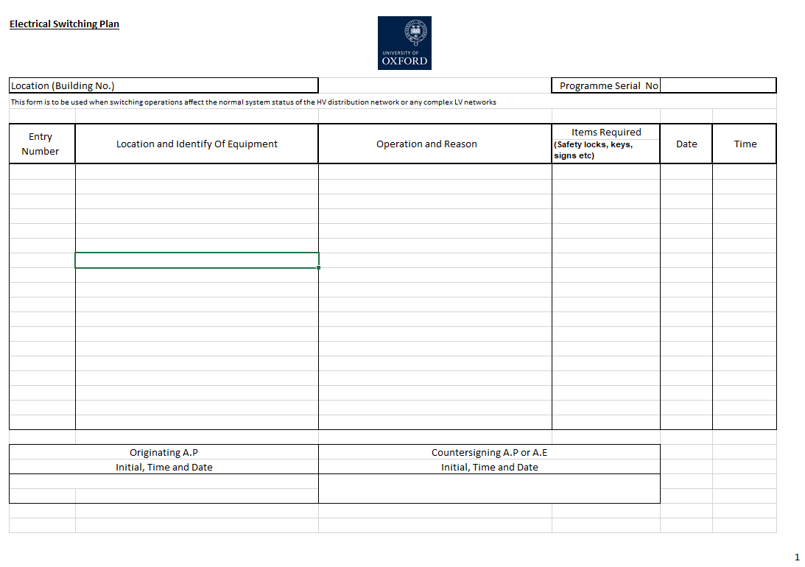

* 1. Isolation & Earthing Diagram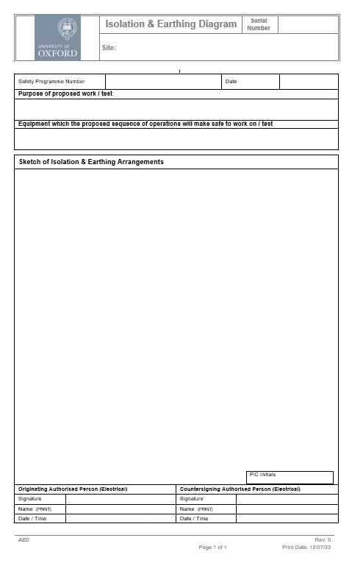
  2. Permit to Work (Electrical) 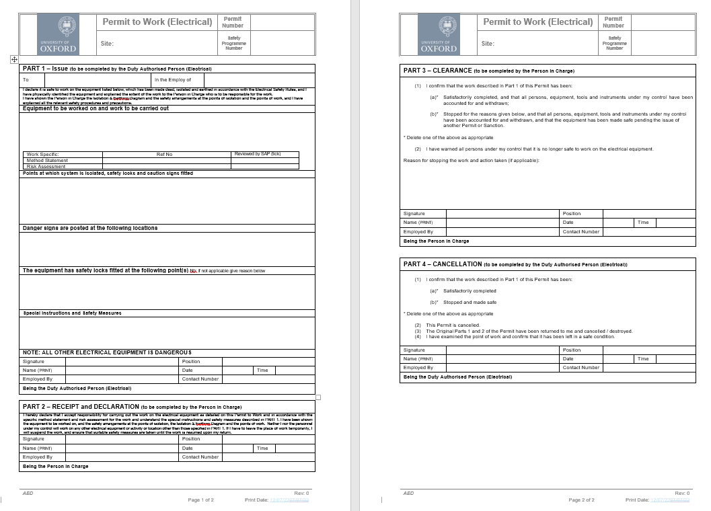
  3. Sanction to Test

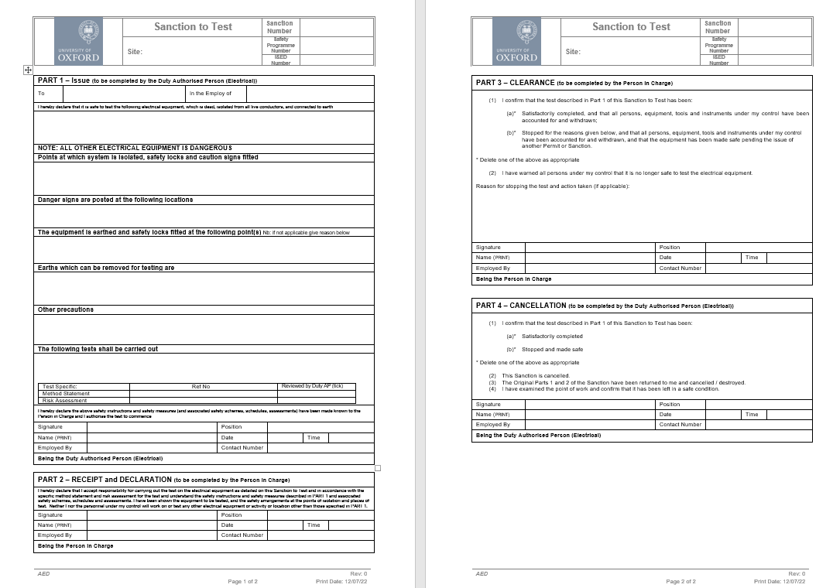

* 1. Certificate for Live Working

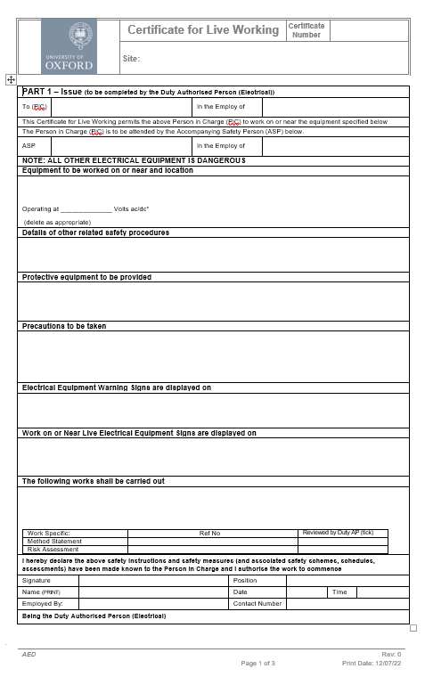

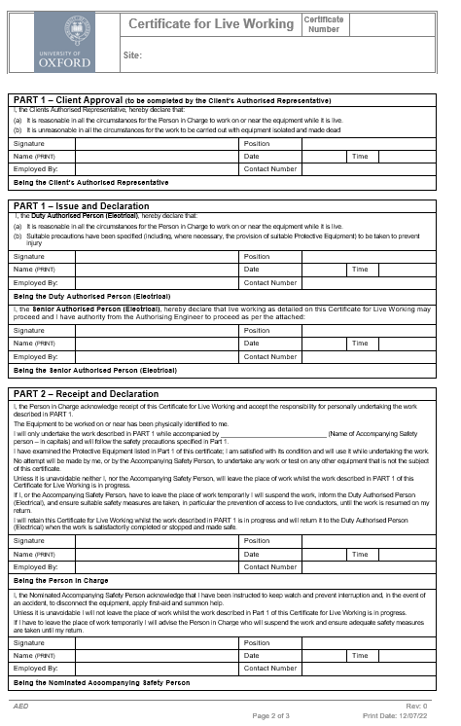

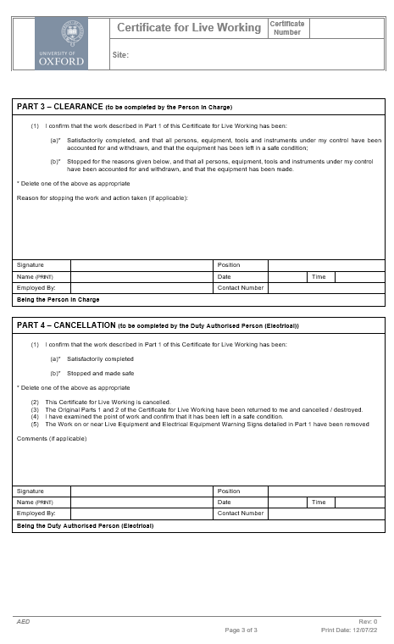

* 1. Limitation of Access

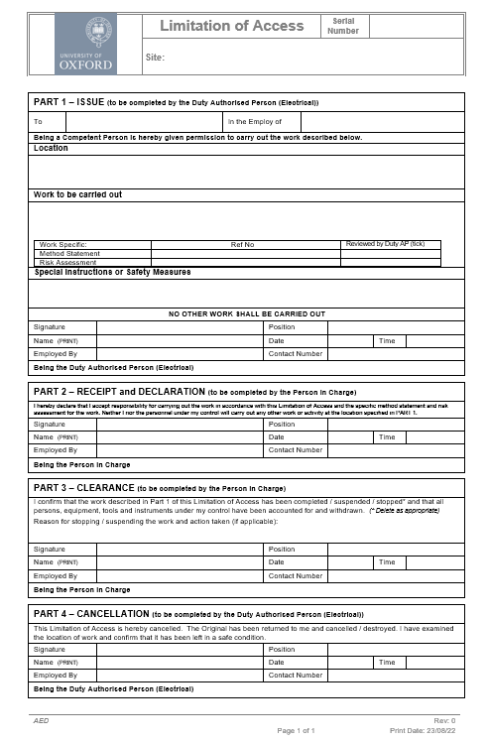

* 1. Certificate of Isolation & Earthing

`````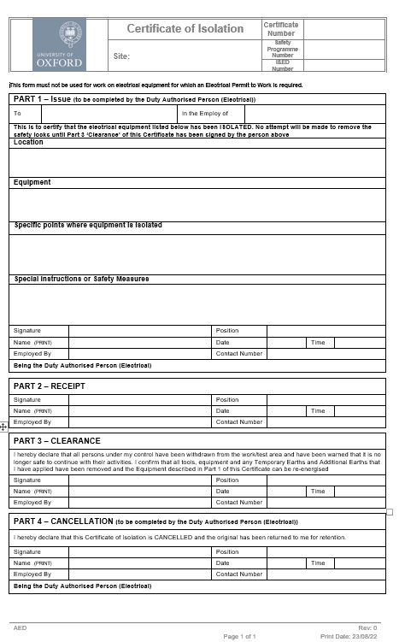

* 1. Standing Instruction

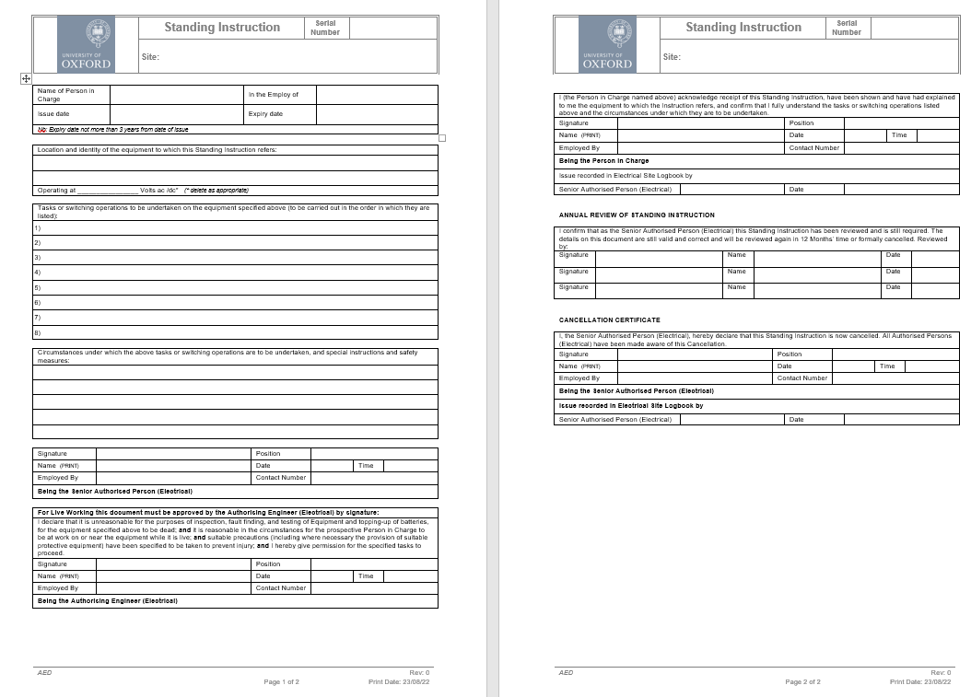

* 1. Statement of Site Familiarity (Electrical)

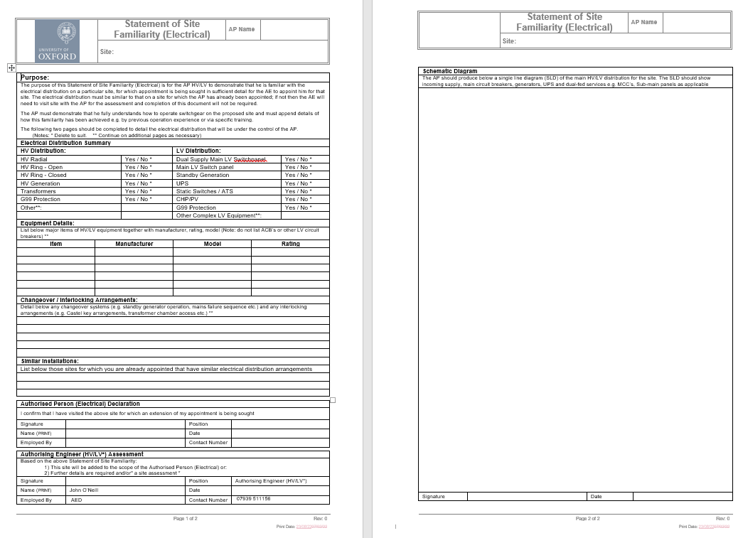

* 1. Demarcation Agreement

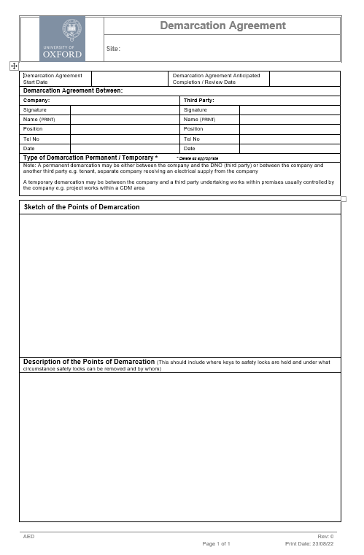

1. appointment documents
   1. Appointment Procedure for an Authorising Engineer (Electrical)

It is the responsibility of the Designated Person to ensure that any person appointed as Authorising Engineer is suitably qualified and adequately experienced to satisfy the requirements of these Electrical Safety Rules.

The appointment of an Authorising Engineer is to be by an exchange of letters.

**Model letter for appointing an Authorising Engineer (Electrical):**

|  |
| --- |
| Dear ______________________ *(Name of prospective Authorising Engineer)*  **OFFER OF APPOINTMENT AS AUTHORISING ENGINEER (ELECTRICAL)**  Being satisfied that you are suitably qualified and meet the requirements of the OUES Electrical Safety Rules, I hereby offer you the appointment of Authorising Engineer (Electrical) to undertake the duties set out in the OUES Electrical Safety Rules.  This appointment shall be reviewed and reconfirmed at four-yearly intervals.  Please confirm your acceptance of this offer of appointment by signing and returning to me a copy of the attached letter.  Yours sincerely  ___________________________________  *(Designated Person)* |

**Model letter for accepting an appointment as an Authorising Engineer (Electrical):**

|  |
| --- |
| Dear _____________________________ *(Name of Designated Person)*  **ACCEPTANCE OF APPOINTMENT AS AUTHORISING ENGINEER (ELECTRICAL)**  I acknowledge receipt of your letter dated _____________ offering me appointment as an Authorising Engineer (Electrical).  I confirm that, to the best of my knowledge, I satisfy the requirements for appointment as an Authorising Engineer (Electrical) detailed in the OUES Electrical Safety Rules.  I accept the responsibilities of the Authorising Engineer (Electrical) and will, to the best of my ability, carry out the duties of the Authorising Engineer (Electrical) as set out in the OUES Electrical Safety Rules.  I note that I am required to attend an Authorising Engineer (Electrical) training course at intervals not exceeding four years, and an Authorised Person (Electrical) refresher course at intervals not exceeding five years.  Yours sincerely,  __________________________  *(Authorising Engineer)* |

* 1. Senior AP (HV/LV) Competency Certificate
  2. AP HV Competency Certificate
  3. AP LV Competency Certificate
  4. Authorisation of Appointed Person Certificate

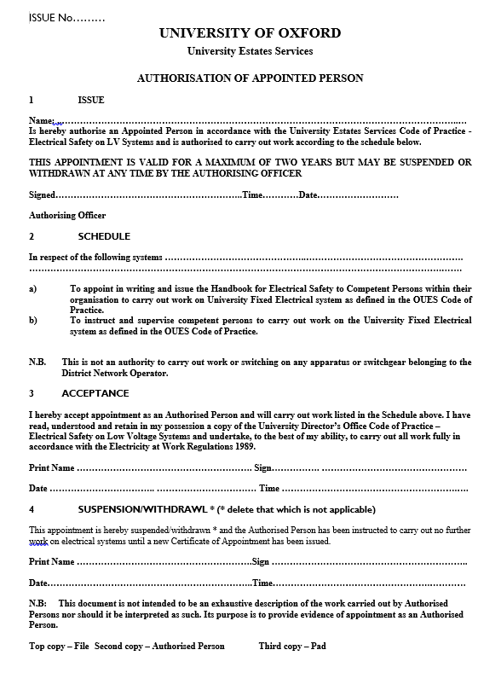

1. abbreviations, terminology and symbols

The following abbreviations, symbols and terminology shall be used in the production of all safety documents.

* 1. Abbreviations

ACB Air Circuit Breaker

ASP Accompanying Safety Person

CB Circuit Breaker

CI&E Certificate of Isolation and Earthing

CN Control Notice

CS Caution Sign

DS Danger Sign

GCB Gas Circuit Breaker

I&ED Isolation & Earthing Diagram

MCB Miniature Circuit Breaker

MCCB Moulded Case Circuit Breaker

POI Point of Isolation

POW Point of Work

POE Point of Earth

PTW Permit to Work (Electrical)

SKB Safety Key Box

SL Safety Lock

SLD Single Line Diagram

SP Safety Programme

TX Transformer

ToSC Transfer of System Control

VCB Vacuum Circuit Breaker

WL Working Lock

* 1. Terminology

Most LV electrical isolators are identified as ON or OFF, whereas HV and some LV switchgear control switches / push buttons may be labelled ‘Open’ or ‘Close’, with the circuit breaker position indicator indicating ON or OFF. However, to standardise the recording of switching operations the following are the preferred terms which should be used depending upon the type of switchgear being operated and the safety document being used:

| **Safety Programme** | **Isolation & Earthing Diagram** |
| --- | --- |
| **Switch to Off**  **Switch to On**  **Switch to Earth** | **Switched to Off**  **Switched to On**  **Switched to Earth** |

* 1. Symbols

Note: It is acceptable to vary the earthing arrangements depending on the orientation of the drawing. Earthing provision not shown in ON or OFF positions for clarity. Symbols below do not necessarily conform to BS or EN standards but are intended for ease of use.

**W**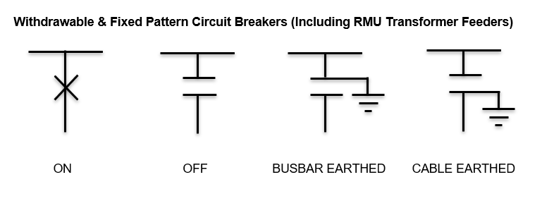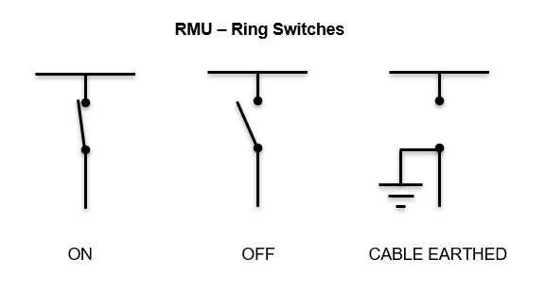

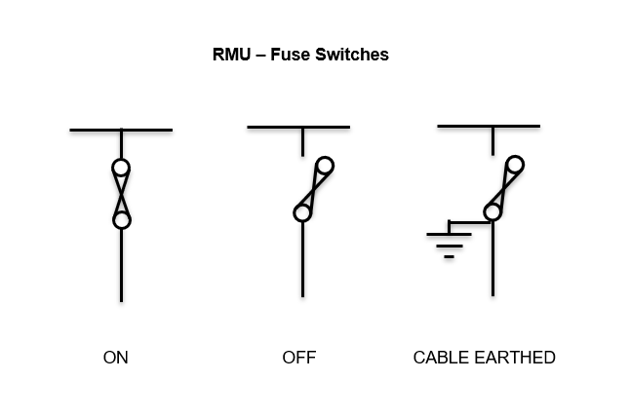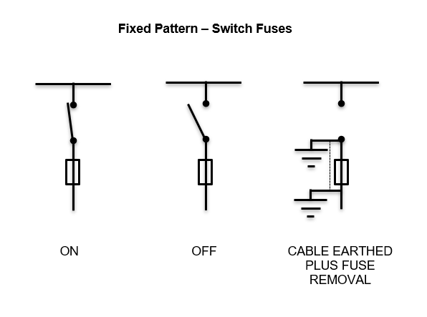

1. Model Safety Signs
   1. Design Specification

All signs, except sign, shall be to the sizes indicated.

Sign P1 to be designed to the proportions prescribed in the Electricity Safety, Quality and Continuity Regulations 2002.

The design and colours of the signs shall be to British Standards 5378: 1980. Colours shall be to British Standard 5252: 1976 as follows:

Yellow 08E51

Blue 18E53

Red 04E53

Signs shall be manufactured from laminated plastic, minimum 1.5mm thickness; or other similar non-metallic weather resistant material, thickness appropriate to the intended location and application.

Non-corrosive materials are to be used when fixing permanent Safety Signs. Permanent signs shall not be fixed with adhesives.

All temporary signs shall be provided with two 5mm diameter holes for a suspending cord. The holes shall be 10mm from the top edge and 30mm from each end for 150mm wide signs, and 50mm from each end for 200mm wide signs. Temporary signs shall be suspended on non-conducting cord.

Model sign images are provided for guidance only and are not drawn to scale

* 1. Permanent Safety Signs - HV

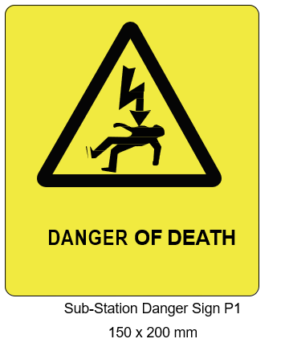 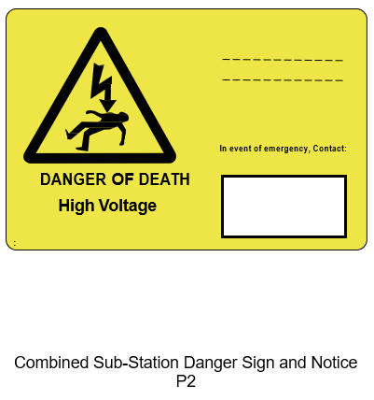

* 1. Permanent Safety Signs - LV

|  |  |
| --- | --- |
| Permanent safety sign - main intake switch | Permanent safety sign stating 'This equipment has more than one source of supply' |
| Main Intake Switch Sign - 200 x 150 mm | Multiple Supplies Sign - 200 x 150 mm |
| Permanent safety sign reading 'DANGER - Generating Set starts remotely/automatically' | Permanent safety sign reading "Danger -400 volts" |
| Remote/Automatically Controlled Generating Set Sign - 200 x 150 mm | Danger Sign – Electrical Plantrooms / Risers |

* 1. Temporary Safety Signs

|  |  |
| --- | --- |
| Permanent safety sign reading "Caution - persons working on equipment - do not switch on" | Image showing a lockable caution sign warning "DO NOT OPERATE", for use on LV radial circuits |
| Caution Sign - 200 x 150 mm | Caution Sign (Typical) – LV Radial Circuits only |
| Permanent safety sign reading "Danger - live electrical equipment - do not touch" | Permanent safety sign reading "Danger - high voltage enclosure. Keep out - authorised access only" |
| Danger Sign - 200 x 150 mm | High Voltage Enclosure Sign - 200 x 150 mm |